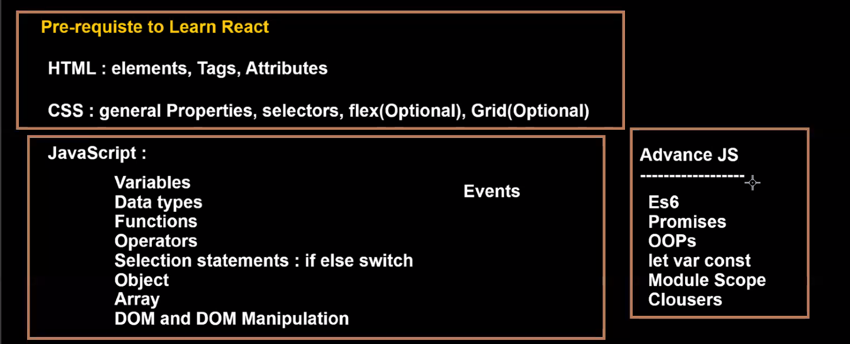

React is a Library.React is not a framework.

A library is a collection of predefined classes, functions, objects. The library is created using JavaScript language.

React JS is a JavaScript library.

What is the purpose of React JS?

React JS is used to create User Interface.Creating User Interface is only just one part of Front end application.

Using React we can create static User Interface and dynamic UI.

Using only React we cannot create a Front end application.

To create Front end , along with React we have to use some additional libraries.

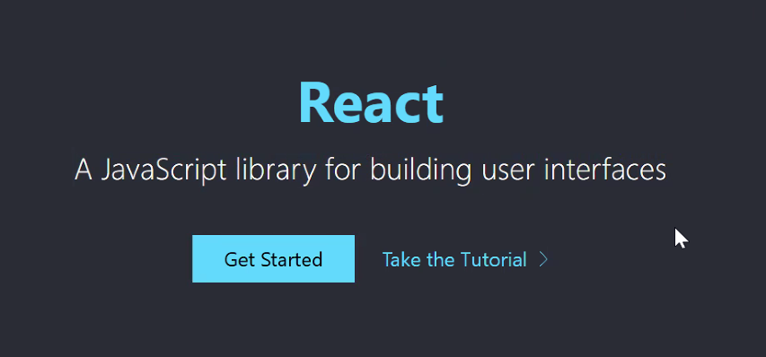

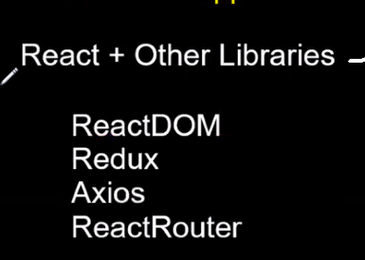

<https://legacy.reactjs.org/> --- old documentation

<https://react.dev/blog/2023/03/16/introducing-react-dev> -- new documentation

Along with React the above libraries are used to create Front end application .

Version 18 is the latest version of React.

**Official website for React**

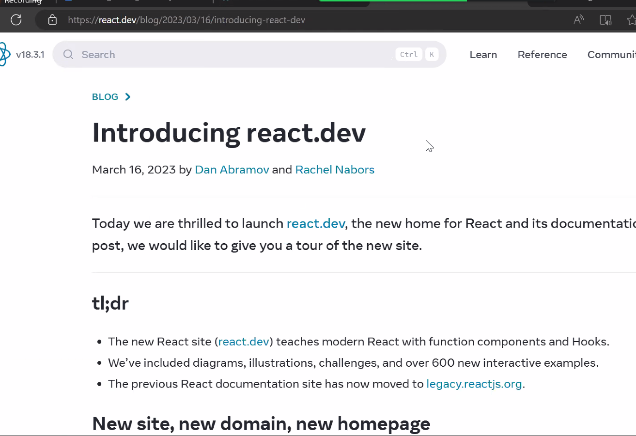

**Interview question**

**When you already have HTML and Java script to develop User Interface, why are we using React again?**

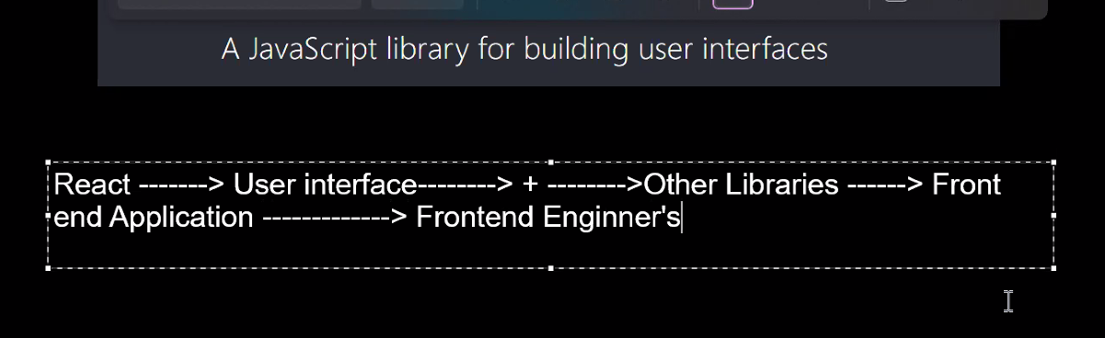

React is used to build or create User Interface

User Interface is a collection of UI components.

By using HTML also, you can create UI.Using JavaScript also we can create User Interface.

Then again why are we learning React to create UI?

Create a simple Button using HTML

HTML provides Button Element --Button Tag

Create a simple Button using JavaScript

JavaScript provides some predefined objects and functions.Using those predefined functions and objects we can create DOM Button Element.and add that DOM Button Element to DOM.

To create any DOM element in Javascript, we have to use document.createElement(‘button’)

If you create button using HTML, you call it HTML button element.

If you create button using JavaScript, you call it using DOM button element

In Javascript, using which method we can create a button?

We can create a button in HTML using only one line of code.

We can create a button in Javascript , we have three lines of code

Therefore, creating a button in HTML is easier compared to JavaScript.

In HTML, we rewrite the code . For example if we want to create alist of names and display it 4 times on UI, we rewrite HTML code 4 times.

Where as in Java script we write the code in a function and we call the function 4 times

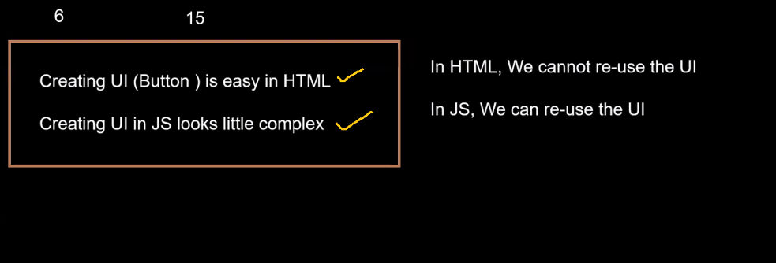

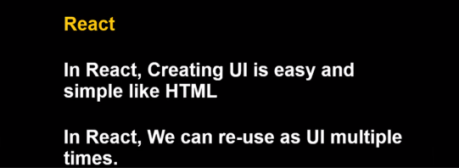

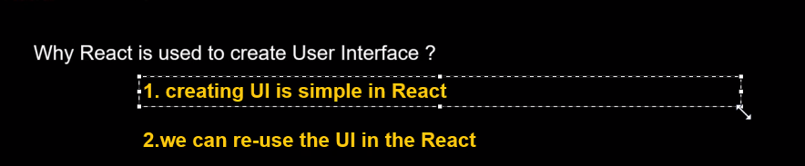

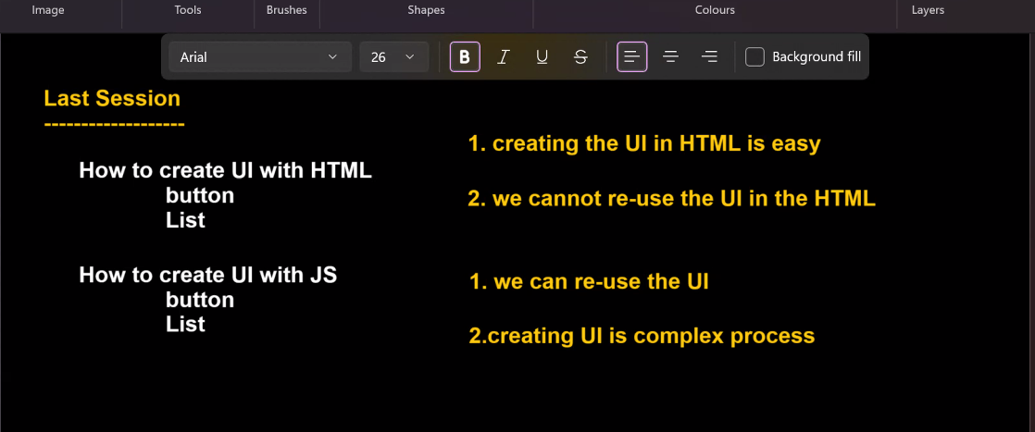

**SESSION-3**

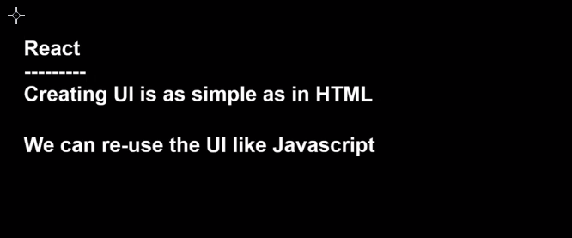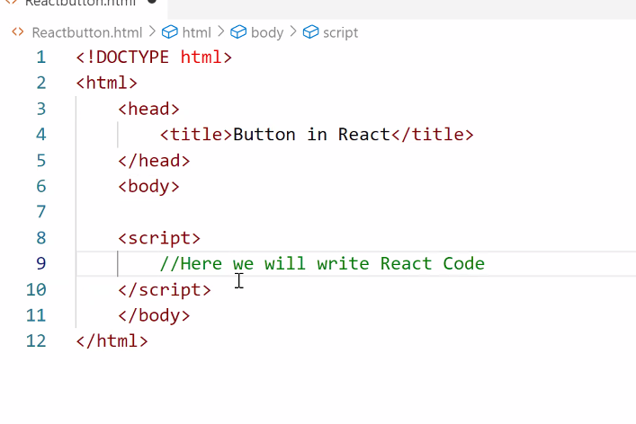

Inside the script tag, we will write REACT code

**Integrate REACT JS with HTML document**

To connect Javascript file to HTML file, we will use SCRIPT tag and give src=path of JS inside HTML file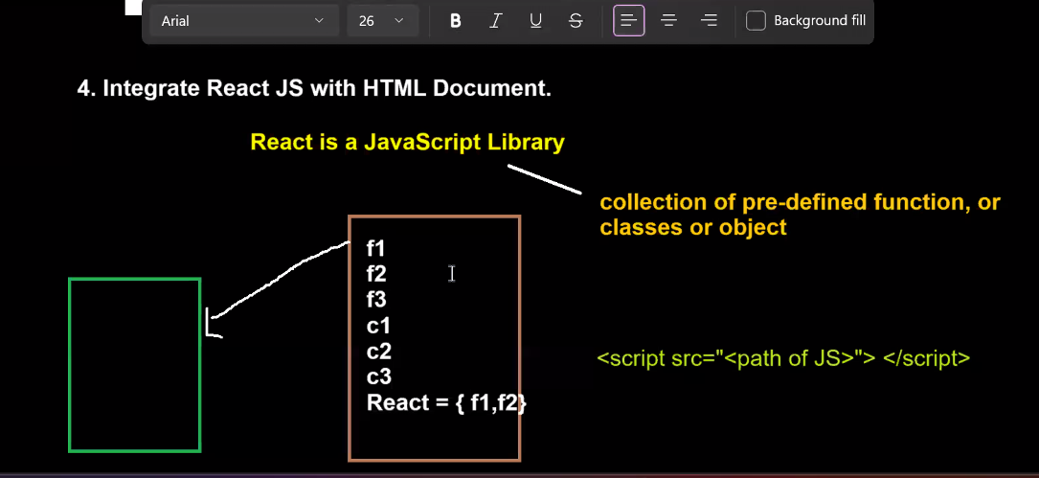

To get the link, go to **<https://legacy.reactjs.org/>**

On the right side, click on CDN links.

Copy the first link

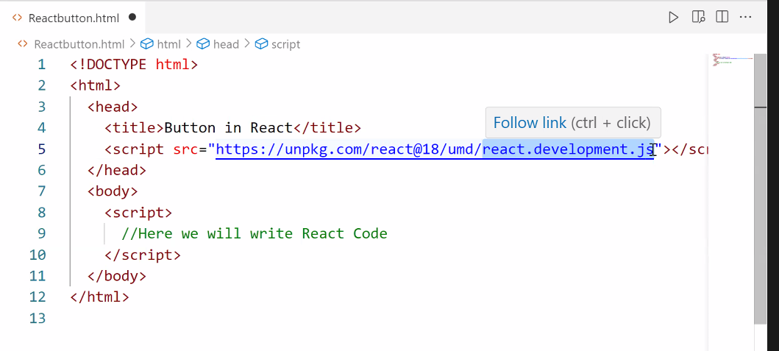

HTML is providing HTML elements to create UI

JS is providing pre-defined object and functions to create DOM elements. REACT elemets are very similar to DOM elements.Add them to DOM.

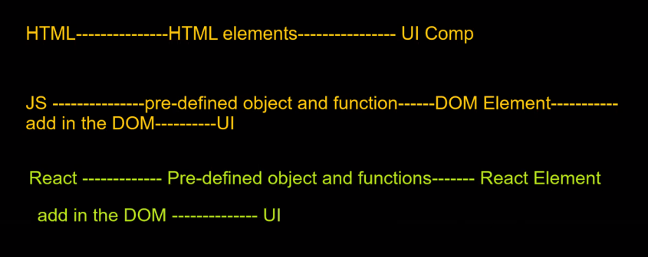

Childrens are something present in between opening tag and closing tag

In the above pic, for HTML tag---head, title, script are children

“Button in React” is child for <t>

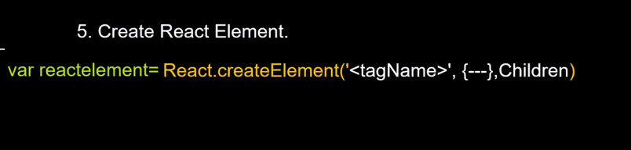

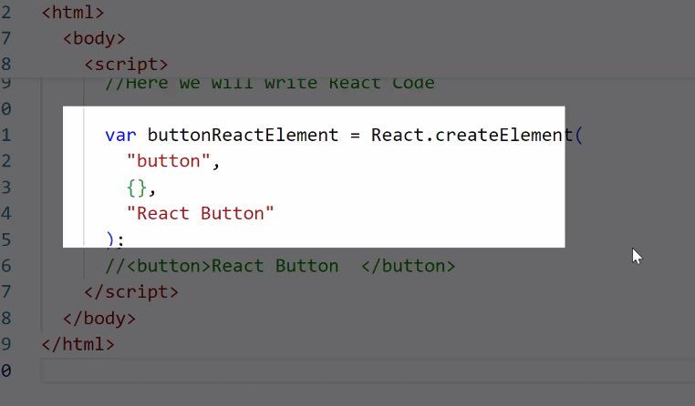

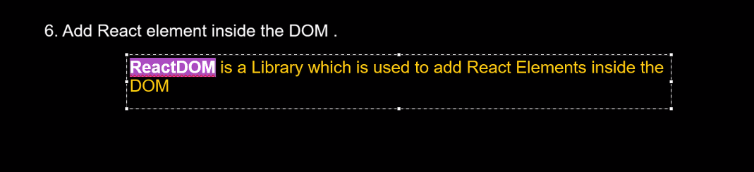

Integration of REACT DOM with HTML document

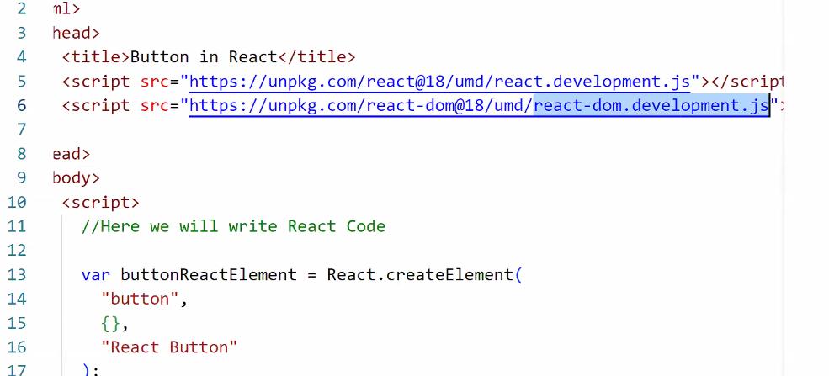

When you want to add React element inside the DOM, you have to integrate ReactDOM with HTML document.

As mentioned earlier, using React you can only create button.To add it to DOM, you need additional libraries.

React library: To create elements

React DOM: To add elements to DOM.

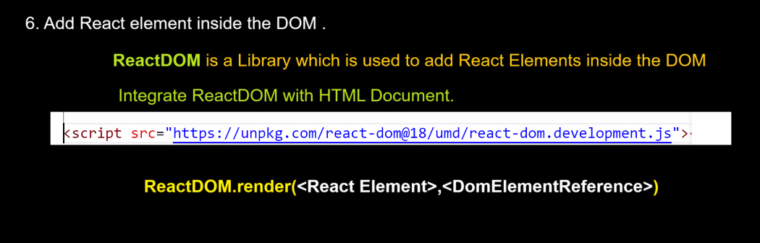

DomElementReference: In your React, where you want to add the react element.

ReactDOM.render(buttonReactElement,document.getElementById(‘body’))

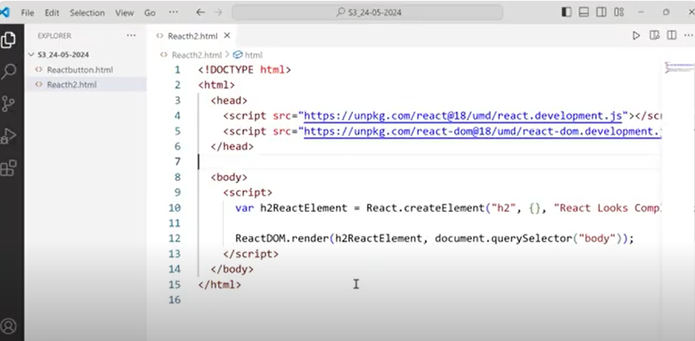

**Creating UI in REACT is simple or complex?**

JSX--- Javascript and XML

Babel compilers convert JSX elements to REACT elements.

Then REACT elements will be given to ReactDOM and ReactDOM will add it to DOM

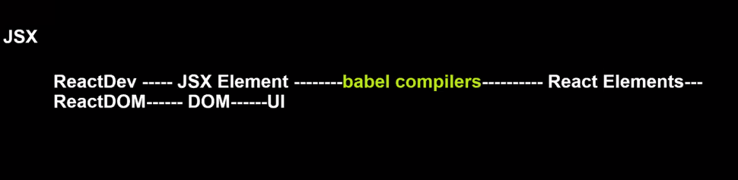

Instead of creating REACT elements, we create JSX elements and JSX elements are 95% similar to HTML elements

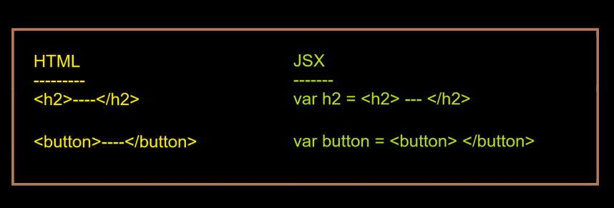

Due to JSX, creating UI in REACT became very easy

**SESSION 4**

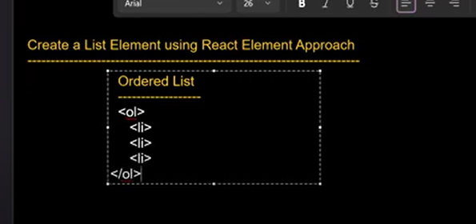

**How to configure the attributes in React elements?**

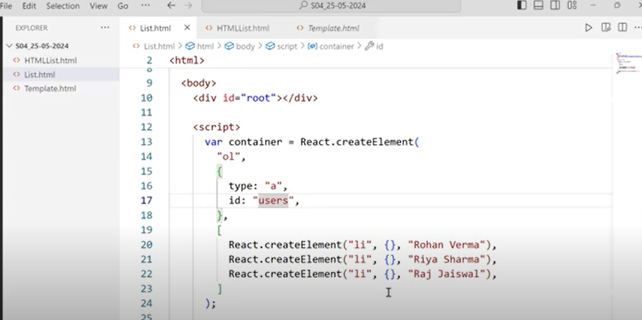

**How to add inline CSS in React?**

In React, whenever you are using Style attribute,its value should be one object.

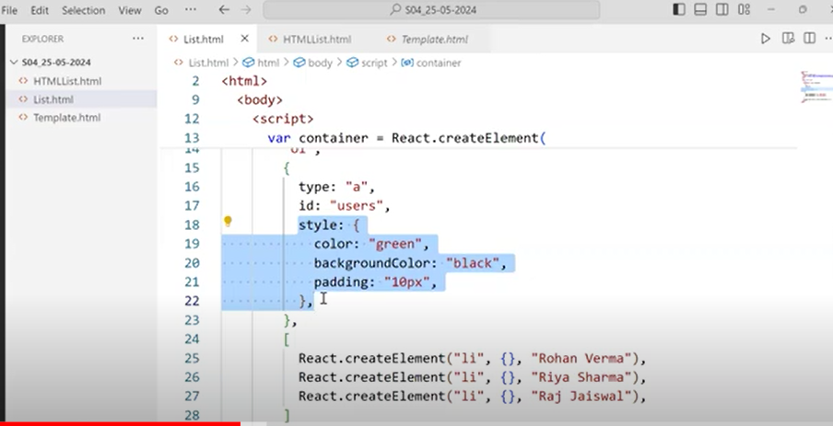

As a developer, we are creating ReactElements uisng React and then adding those React Elements to DOM using ReactDOM and UI is created.

This process looks complex.

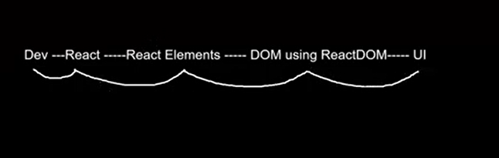

To make it easy, we started a new approach

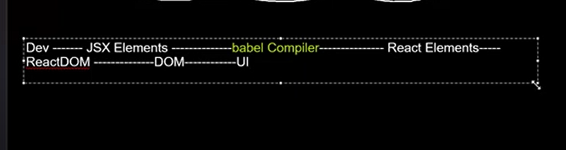

JSX elements are very much similar to React elements and babel compiler converts JSX elements to React elements.

**How to create button with JSX?**

Along with REACT and REACTDOM, we will also integrate BABEL with HTML document.

Go to this link:  **<https://babeljs.io/>**

Click on **SetUp** and click on **In the Browser.**

Scroll down and copy the script tag

<https://unpkg.com/@babel/standalone/babel.min.js>

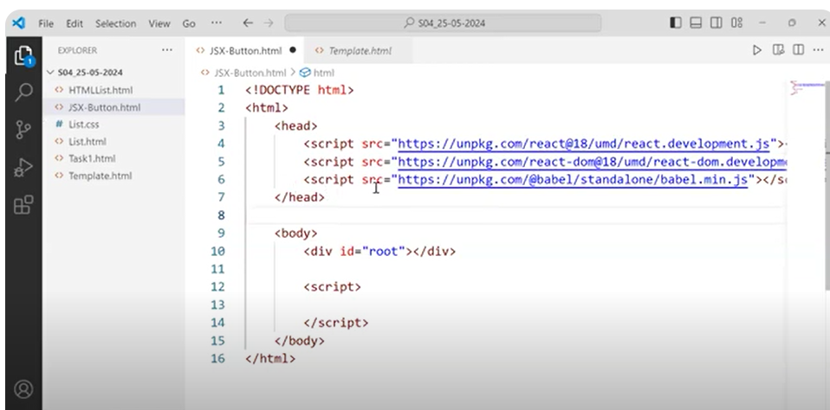

Add type =”text/babel” in script tag

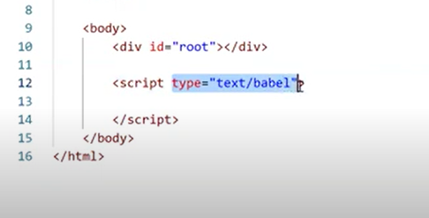

Inside your script tag, if we you are writing any HTML code, then it is called JSX.

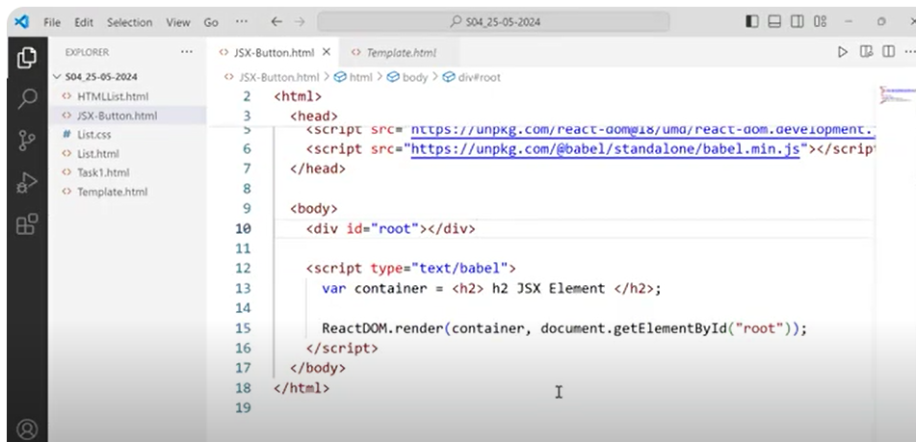

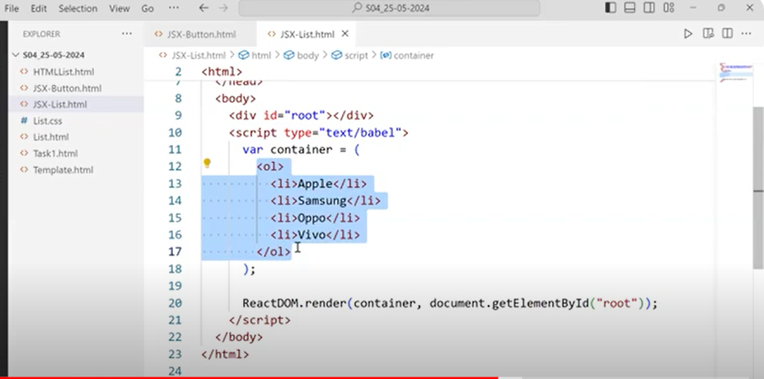

Add marker ‘a’

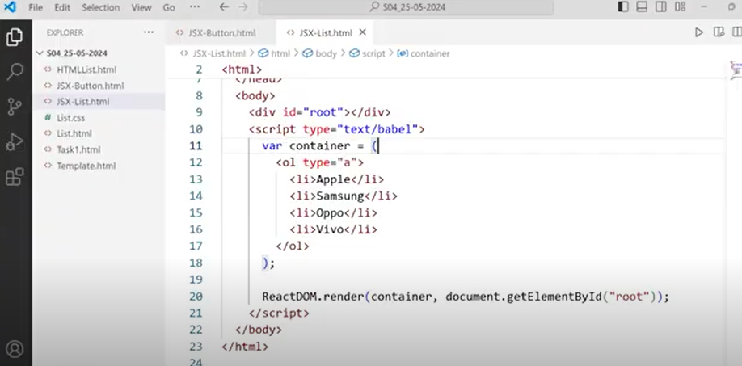

Just for developers convenience, we are writing UI code in JSX.But at the end, JSX code should get converted to REACT elements and BABLE will take care of that.

**SESSION-5**

**Default width and height of div is**

**Width: 100%-- by default width occupies full screen**

**Height: Depends on children**

In order to make div look like a card, decrease width of div to some value and increase height of div to some value.

We can add CSS in three ways.-- Inline CSS, Internal CSS,External CSS

ReactDOM is a library which helps us to add elements inside DOM.

The moment ReactDOM encounters JSX element card, it will ask Babel to convert that JSX element to React element.Babel will convert that JSX element to React element and add it to DOM.

Inside your JSX, if you want to use JavaScript code, you need to use {} and inside the curly braces, you have to write your Javascript code

You can assign Java script code to your JSX elements attributes also.

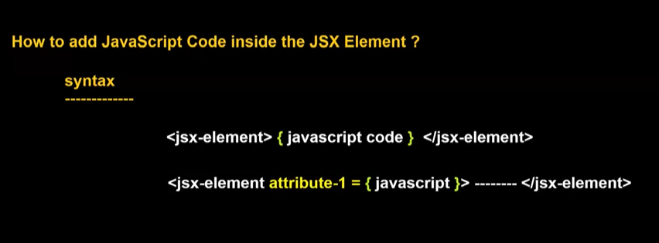

Therefore, you can use Javascript code inside JSX elements.This type of ability you don’t have in HTML.

Inside HTML code, you cannot write Javascript code.

To HTML attributes, you cannot assign Javascript elements or functions.

Where as to JSX attributes, you can assign Java script elements or functions.

To display cards in a single row, we have to use CSS.

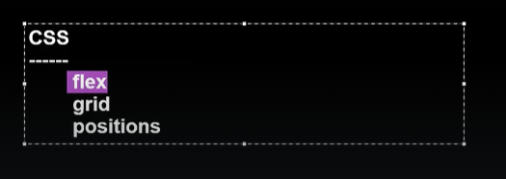

Direct child of a flex container are called Flex items.By default Flex items will display in row direction.

To generate equal space between all cards, we can use **justify-content:space-evenly**

**Study flex concept in CSS**

**How to pass different data in each card?**

One of the easiest way is we can use functions.

How to create UserInterface inside a Javascript function?

**SESSION-6**

**So far concepts learned**

**How to create simple card using JSX?**

**How to reuse UI?**

**How to create UI inside Javascript function?**

**How to pass dynamic data to UI?**

**<script type=”text/babel” ></script> ==here attribute -> type = “text/babel” indicates that we can write JSX code inside script tag**

**If you create your UI inside a Javascript function, then you have two benefits.**

1. **We can reuse our UI**
2. **We can pass dynamic data in our UI**

**Whenever you call the Javascript function, it returns the entire JSX code.**

**BLIND RULE:**

**In React whenever we want to create any UI, then we will always create that UI inside a Javascript function.Even if we want to create a simple button, we will create that button using JSX inside a Javascript function only**

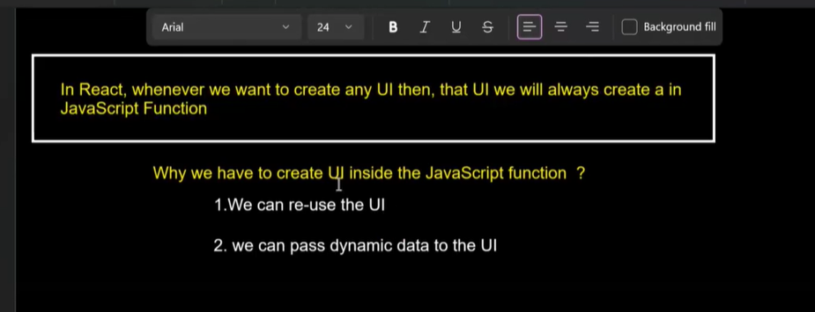

In Javascript, we call a function by using function name.

Ex:function createCard(){

return <div></div>

}

We call above function in Javascript by **createCard()**

**In React we call above function in element format i.e tag format**

**<createCard></createCard>**

**Or**

**<createCard/> ---self closing tag format**

**If you are calling your function in tag format in JSX code, no need to use curly braces inside the JSX elements.**

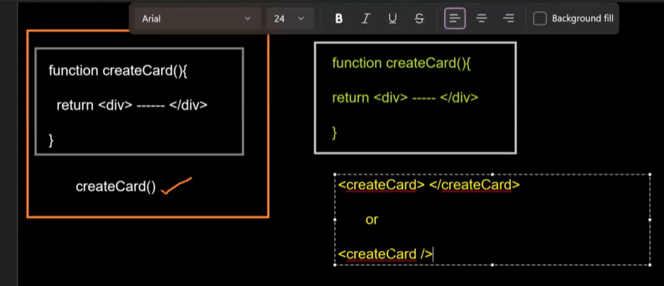

**If you want to call your function in tag format, then your function name should start with Upper case.While defining your function or calling your function the first letter should be capital letter**

**When we use certain libraries or frameworks, we need to follow their rules.**

**Libraries will have little bit of less rules compared to frameworks.**

**In Angular, we have lot of rules.If we use all those rules correctly, we will have a lot of advantages.Only problem is we have to remember all those rules.**

**What is Functional Component in React?**

**It is a simple JavaScript function whose name starts with uppercase and returns User Interface(JSX or React elements)**

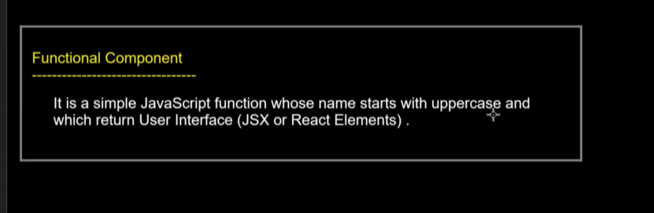

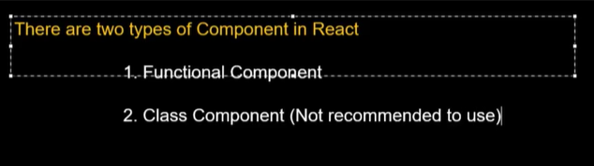

**No one in industry is uisng Class component.Everyone is using Functional component.React itslef recommend us to use Functional component and not Class component.**

**New documentation of React is completely created on Functional component.**

**In Angular also we use a lot of Object Oriented Programming(classes).Slowly they are moving from Object Oriented Programming to Functional Programming.**

**The core reason for moving towards Functional Programming is its simple to create and fast in execution**

**Before 2018, in React everybody was using Class component.After 2018, everybody started using Functional Component**

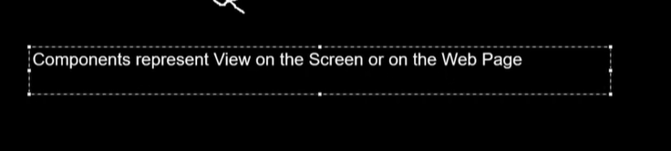

One Web page can have any number of components.

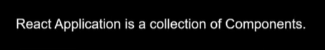

Therefore React and Angular follows Component based architecture

Concepts learned so far..

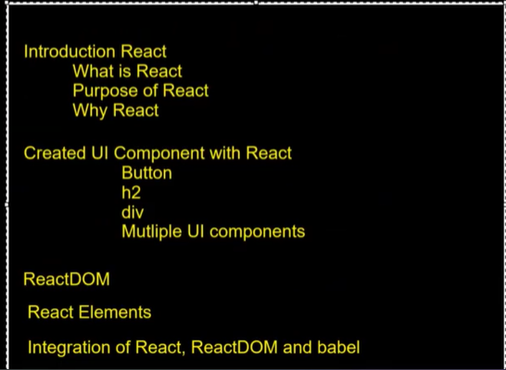

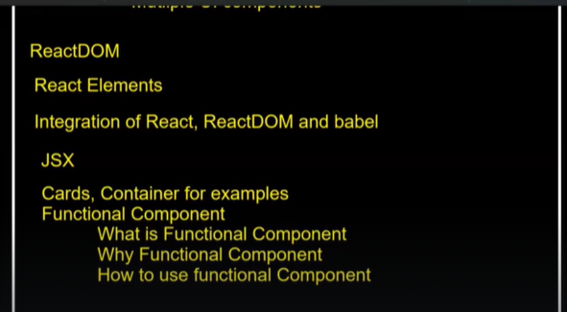

**SESSION-7**

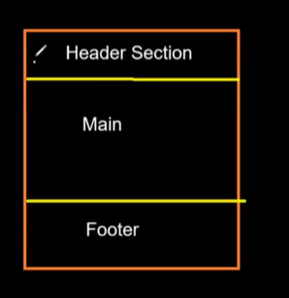

To create three sections as above in React, for every section we create a Component.We can do it by creating one component also.But in future we wont be able to reuse Header section ad footer section.

So as per react, we have to divide our User Interface into smaller components as much as possible so that we can reuse those components whenever and wherever we need them.

**How to link CSS file with HTML document?**

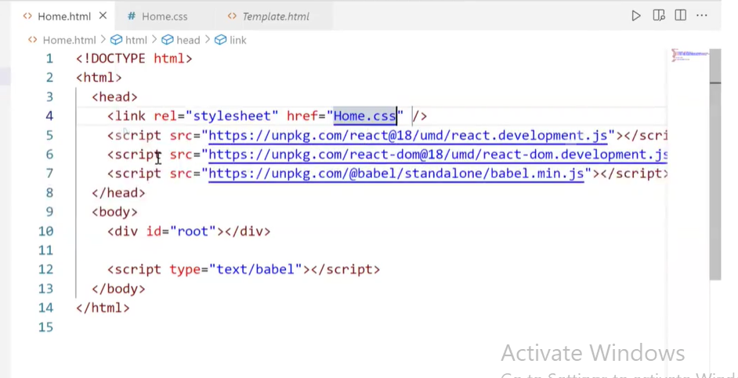

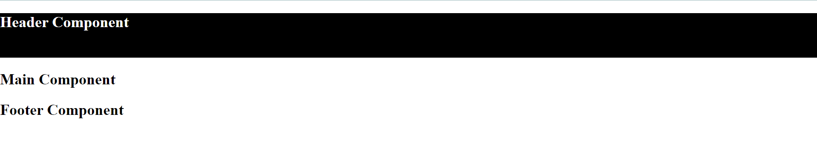

When you want to remove extra spaces , you need to give margin 0.

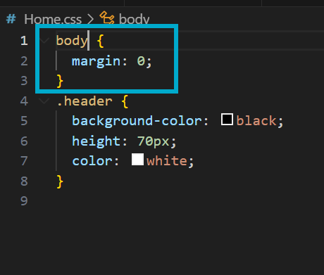

If you want to remove extra spaces for all components, you need to give **\***

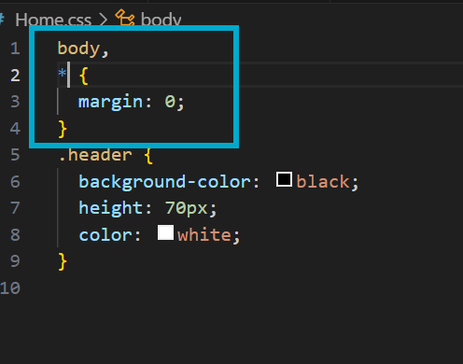

Output looks like below

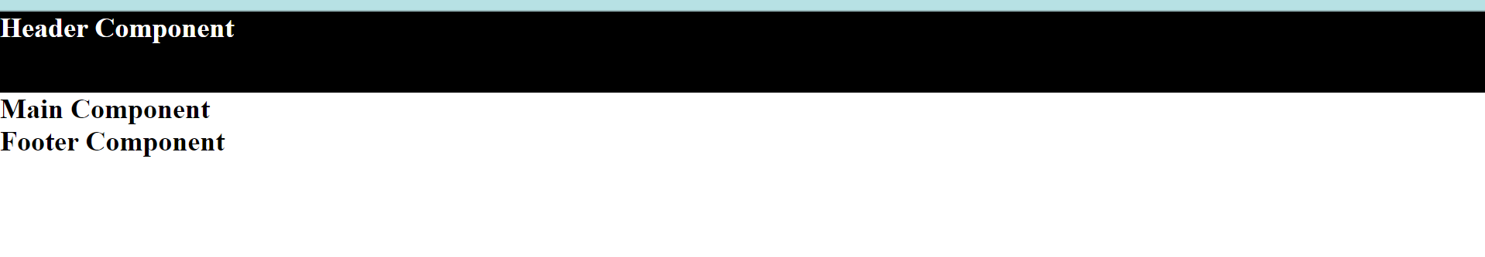

FLEX concept is very important

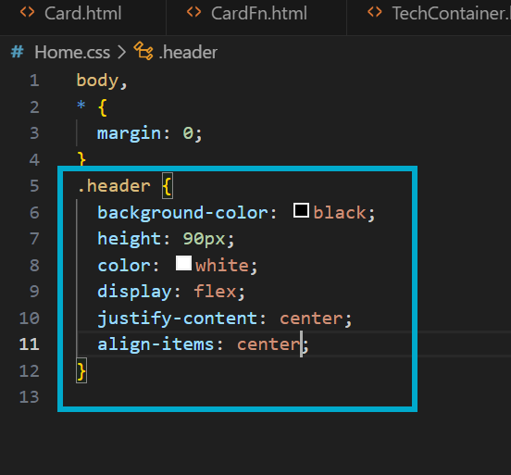

Without adding display:flex, justify-content and align-items don’t work.

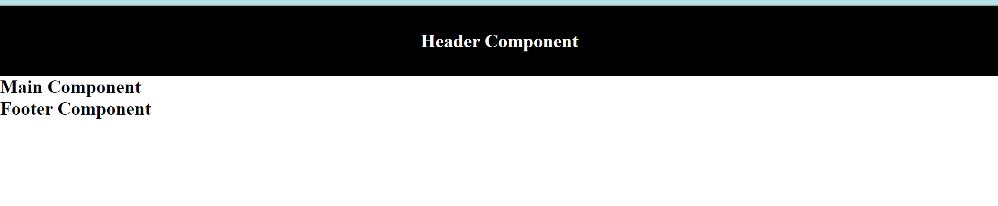

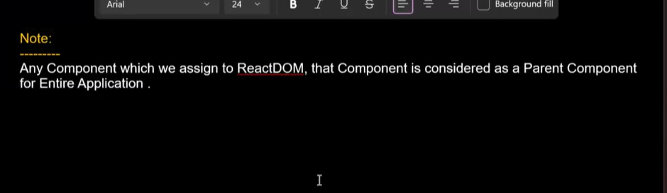

**Rendering = calling --- calls+converting JSX elements into React elements + added in the DOM**

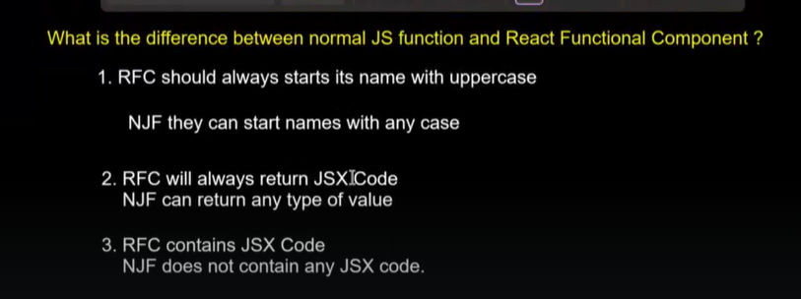

When you are using Java script functions we can use the term “call”

When you are using React Functional components, we can use the term “Render”

**If the component is a class, then for styling in CSS you have to use .class name.**

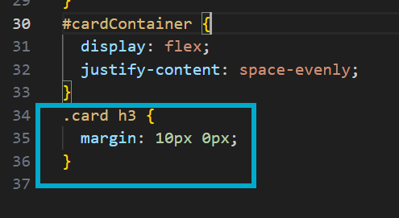

How to pass dynamic data to your component if you are calling in the element format?

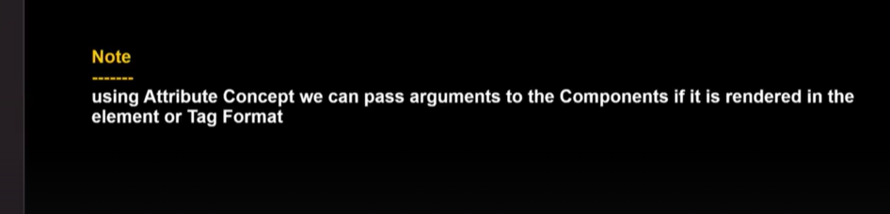

In normal HTML, we call it as Attributes.In React we call it as Props.

The first parameter inside the Functional component is always the Object and inside this object your Props will be stored.(Props will be stored like properties inside the object)

People prefer to keep the name of the first Parameter as Props

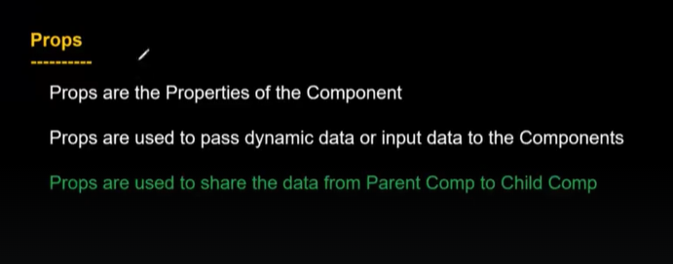

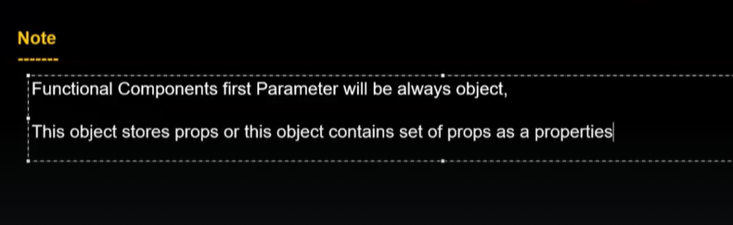

Interview question:

Props are not objects.Props are the properties of the component which are stored in one Object.

**SESSION-8**

**How to create a Nav(Navigation) bar?**

**Assignment at 26:01 and 27:17**

**Example of Inline CSS.Here containerStyle is an object.**

**Const containerStyle…. IS JAVASCRIPT CODE**

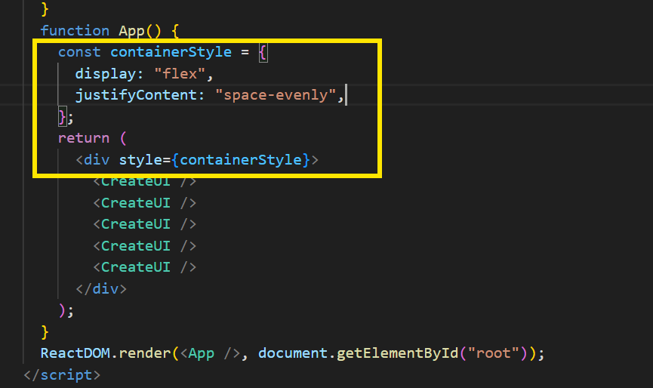

**Concepts learned so far:**

****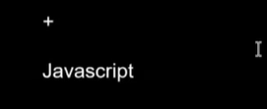

**These are Basics of React and 70 percent of interview will be on these concepts(React Basics+ Javascript Advanced)**

**First they will test your JavaScript knowledge, they don’t ask JavaScript basics, they ask Advanced Javascript concepts.If they feel you are good in Advanced Javascript, then they will ask React questions.If you fail in Javascript, then they will not go to React.**

**If you are good in Advanced concepts of Javascript and basics of React, then they will ask you advanced concepts of React**

**Assignment at 53:31**

**SESSION-9:**

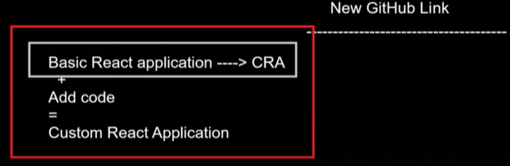

Before we start development of application, we are spending a lot of time in creating the application.

Vite is a tool that helps us to create Basic React Applications.

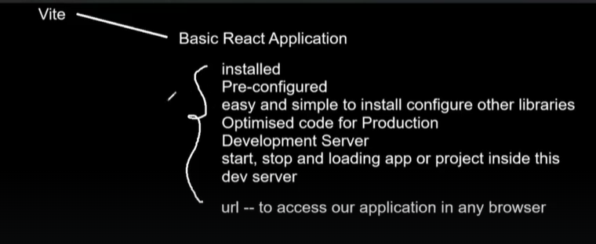

If you don’t use this tool, then manually you have to do all these things.Doing manually all these things will take a lot of time and you need to write a lot of code.

Using CRA also we can create React Application , but it takes lot of time.Performance of application which is created using CRA is a bit slower compared to the one which is created using Vite.

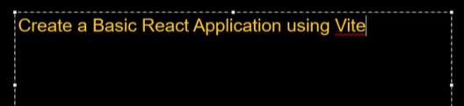

If you want to know more about Vite tool, go to **<https://vitejs.dev/>**

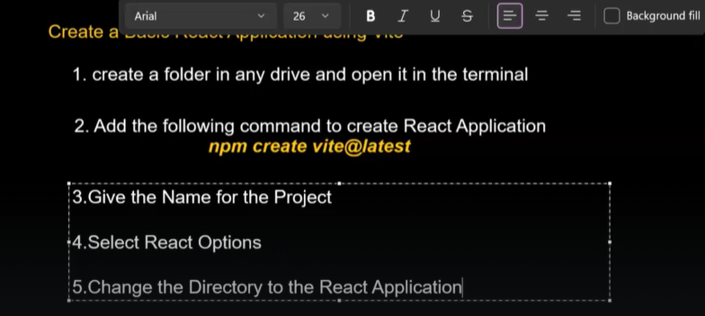

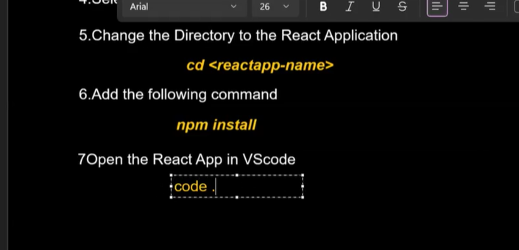

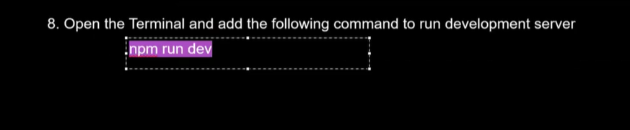

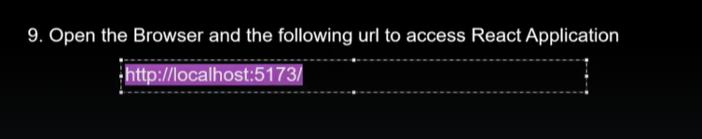

**Create a new folder in one of the drives**

**Open that new folder from Command Prompt and enter the command “**$ npm create vite@latest”

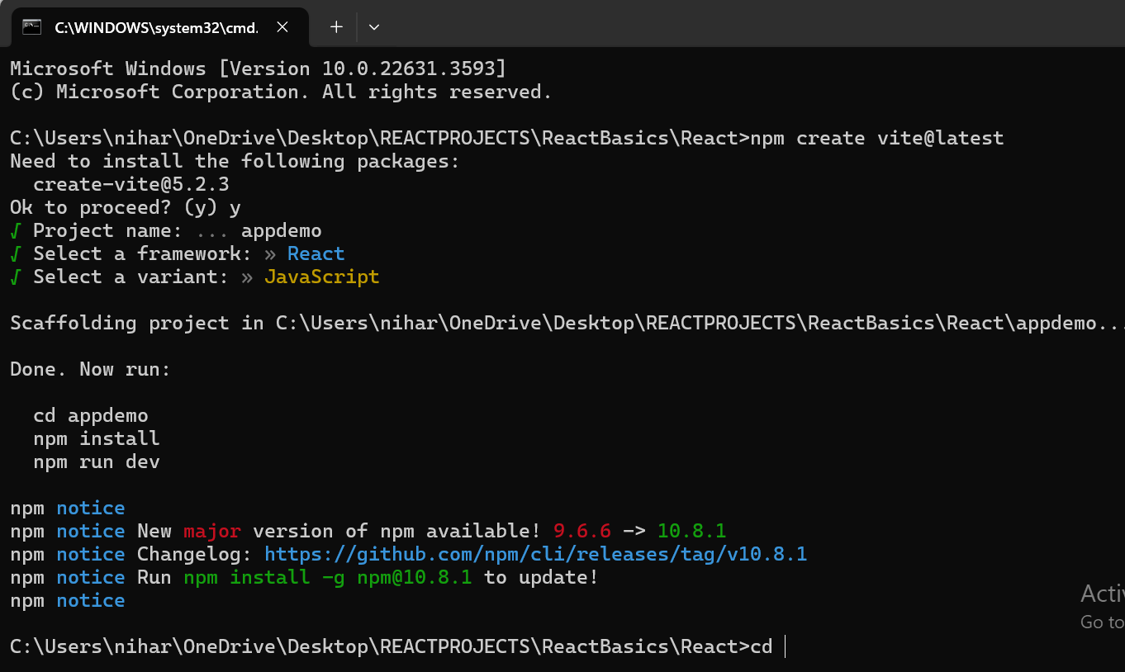

Enetr these commands

Cd appdemo

Npm install

After installing enter code .

Your react application will open in VS code.

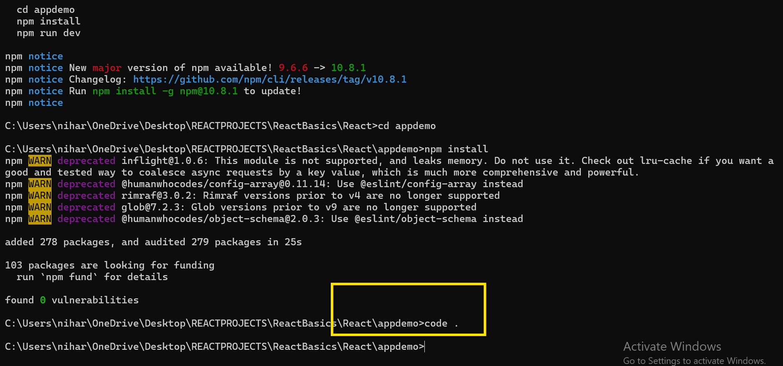

Enter command

**Npm run dev** --- telling Vite tool to start your development server and host this application appdemo in that development server.

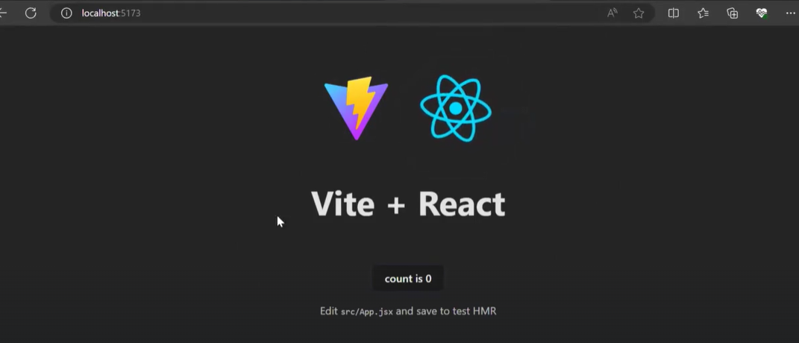

**SESSION-10**

**The moment you give npm run dev command, the Vite tool will start internal development server and will host the application on this server.**

**How to create a React Application using vite?**

**The vite tool creates an App component App.jsx. Inside JSX file you can write Javascript code or JSX code.**

**Inside App.jsx file, they created App component and inside App componnet they created UI.You will find this file inside src folder.**

**In industry this is recommended.**

**1)Basically for every component there should be separate JSX fileor JS file.In file you should have only one component.This is recommended .But if you create multiple components inside one JS file or JSX file, there is no problem.**

**Each component should be present in each file, that file can be JSX file or JS(Javascript)file.**

1. **Your file name and component name should be same.**

**In your application if you are creating 100 components, there should be 100 files.**

**All the components and CSS files are created in SRC folder.**

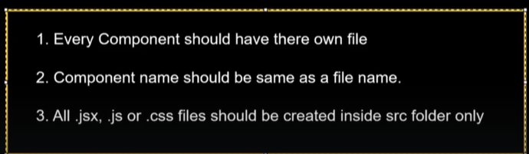

Below is example of Inline styling

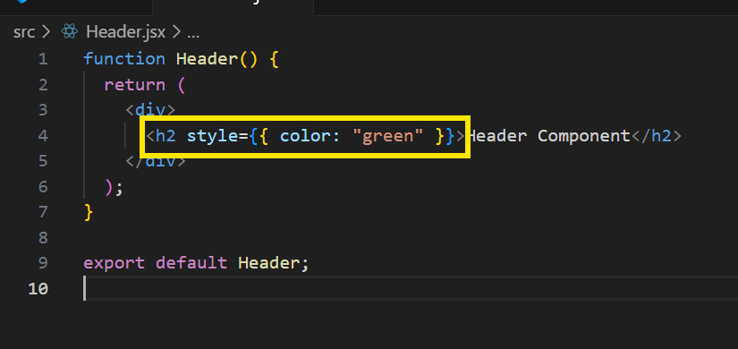

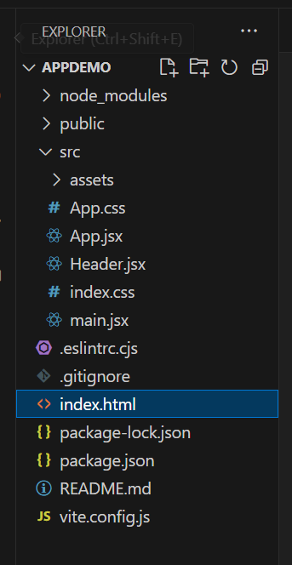

In your react application, index.html is the only html file that is getting loaded when you open the URL.

**What is Browser compatibility issue?**

When the functionality behaves in different ways in different browsers, then that is called Browser compatibility problem.

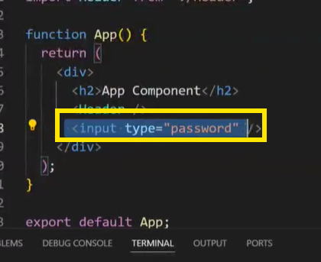

In the above case , the textbox behaves differently in Edge browser and Chrome browser.

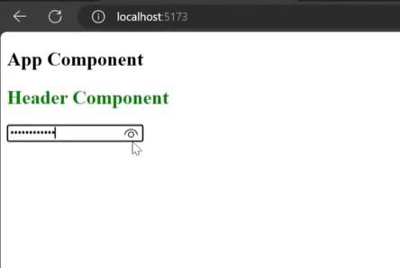

When you type something in that textbox, you get that eye symbol.

When you access same application in Chrome browser, you wont see that eye symbol,

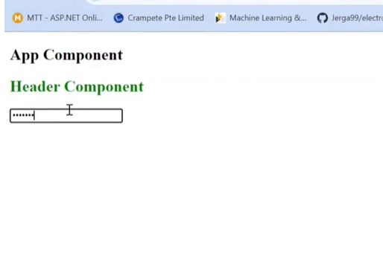

So to get that eye symbol, we did not write any code specifically.It’s the edge browser that has written some code to get that eye symbol.

**This kind of issues we call as Browser compatibility issues.**

**So whenever you are writing code, you have to take care of browser compatibility issues also.You have to give same kind of user experience in all the browsers.**

**Whenever you are developing projects, you will get such kind of requirements also.**

**React is a different library.ReactDOM is a different library and DOM is a different thing.**

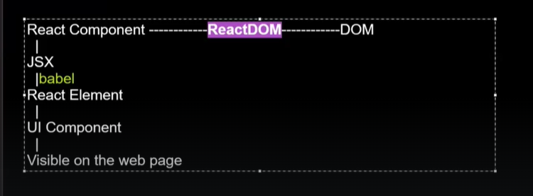

When you create some JSX elements inside the React Component, the babel compiler will convert those JSX elements to React elements.

Based on React elements, UI components will be created if your React elements are loaded into DOM.

Question is who will give React elements to DOM?

If you give React elements to the DOM, only then UI component will be created by browser and visible on web page.

Using ReactDOM, we can load React elements to DOM.

ReactDOM provides a function called render() .You have to access the function by an object ReactDOM.

**ReactDOM.render()**

**Inside main.jsx file we write ReactDOM.render(). ---This code will work till React17 or less than React17 versions.From React 18, this code will not work.**

**Latest version of React is React 18 and soon they are going to release React 19.**

**90% of projects as of now in industry are working on React 16 or React 17**

**Add statement --> import ReactDOM from “react-dom”;**

**The highlighted path is path of library.The library is present under node-modules folder.Vite tool takes care of downlaoding it.**

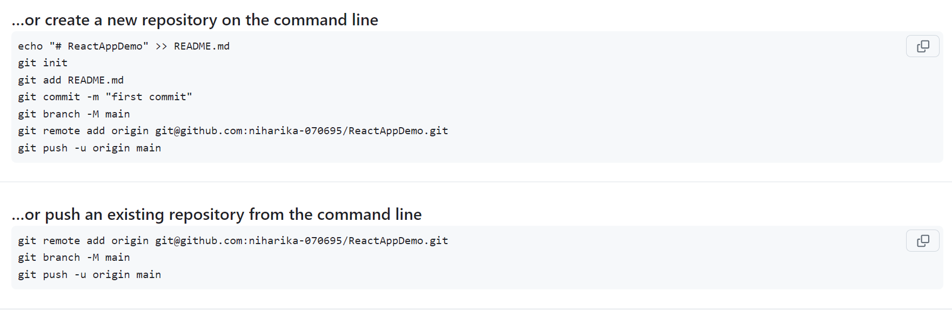

You will have only one HTML file for your entire application.That is called Single-Page-Application.

When you enter the URL, in the web browser index.html file is loaded first

Inside index.html, we are loading our App component.

Inside the App component, we are rendering Header component.

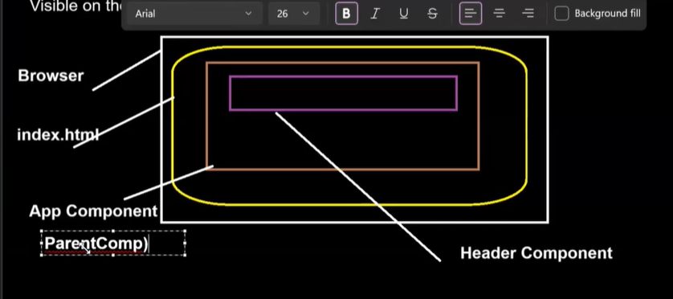

Any component that you give directly to ReactDOM is called Parent component.

Suppose in index.html page, you don’t want to load App component.You want to load directly your Header component

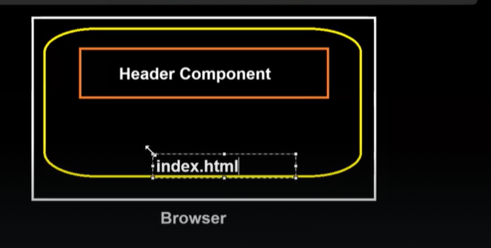

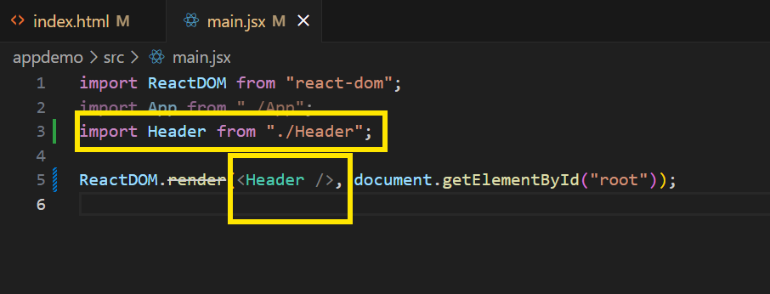

In this case, Header component is the parent component.The component which you are passing directly to render() or ReactDOM is called Parent component of your entire application.

Parent component means it is the first component that will load and later remaining components will load.It totally depends on you which component you want to make as Parent component.

**How to link your CSS file with JS or JSX file?**

**Import “path to CSS file” --- external css**

**In React className is equal to HTML class atrribute.In React and Javascript there is a reserved meaning for keyword class**

**React will force us to use class attribute as className**

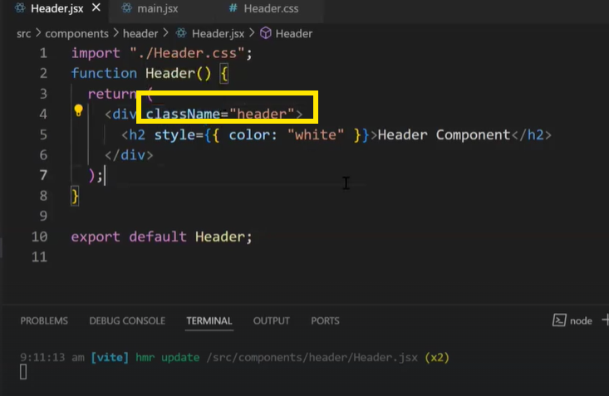

**Adding eventlistener on HTML element**

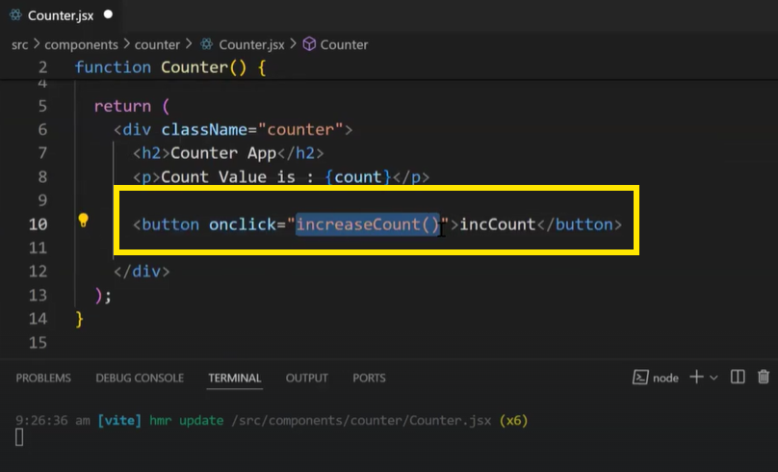

Onclick is event-listener and increaseCount() is event handler.

In React we follow camel-case naming.In JavaScript we add double quotes to event listener as shown in above screenshot.But in React we add curly braces as shown in below screenshot.

And instead of calling the function , we just pass function name .so we don’t add parantheses after the function name

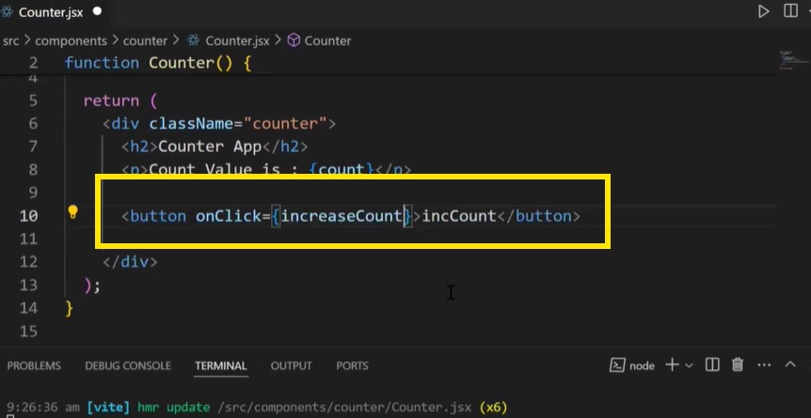

**DOM manipulation**

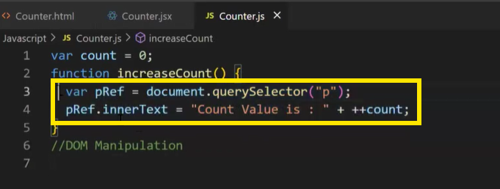

**querySelector is a predefined API.The above highlighted code is DOM code.**

**Right now we are updating only one variable.But if you want to update many components , it will be very difficult to write DOM code.**

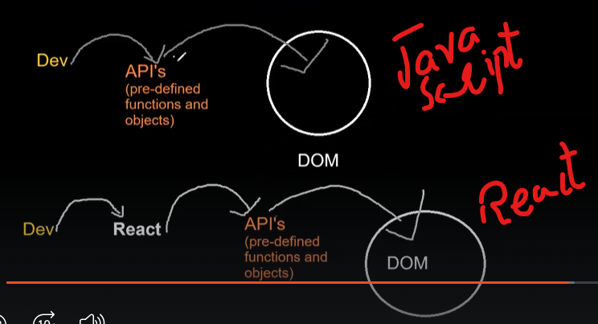

React knows best ways to use these APIs and update DOM compared to developers.

If you are using bad ways to update your DOM, then performance of your application will be less.

As a developer, you will tell to React how your DOM should get updated.

In normal HTML and Javascript, developers directly perform operations on DOM using APIs.But in React and Angular, developers don’t perform operations on DOM directly.Instead they give instructions to React and Angular on how to updated DOMs as per the requirement.Dealing with react is easier compared to dealing with DOMs.This is the main reason where we use libararies and frameworks.

For telling React , how to update DOM, we use a new concept called State in React.

**SESSION-11**

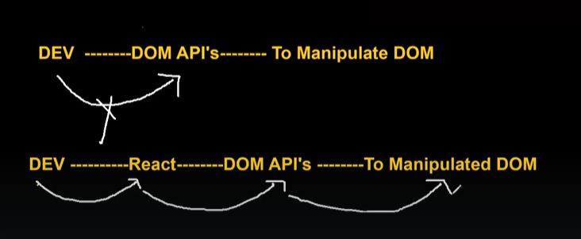

**Whenever you want to change some data on User Interface on performing some action, then that data should come from one special variable called State.**

The data that is going to change on performing some action, only that data should be stored in State.

From state, we have to bind that data with JSX.

Whenever we click on the button, we have to just update our state.Whatever the data you updated in the State, React will take care of updating that data in User Interface.

Initially, you are asking React to show the data present in State in UI.Later when you update the data in State, you are asking React to show that updated data in UI.

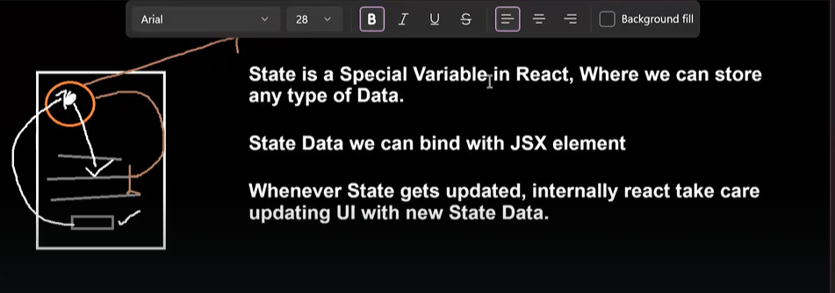

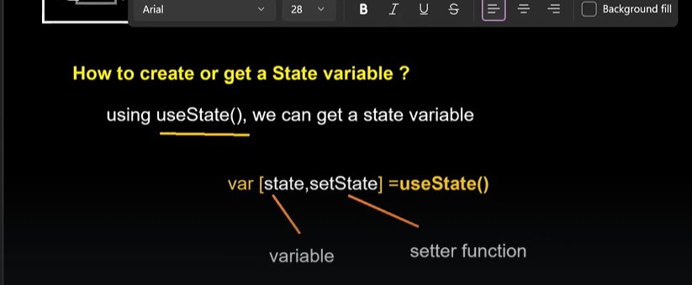

In React, useState() function returns an array.That array has exactly two variables. First variable is state.Second variable is setState.

Inorder to use ‘useState()’ in our components, we have to first import ‘react’ library.The ‘react’ library is present under node_modules folder.

**Import {useState} from ‘react’**

**Var[state,setState] =useState(); //state= undefined**

**=== we are using the concept of JavaScript destructuring**

**In the first variable, state is stored. In the second variable, setState which is a setter function is stored.By default, it will be undefined.**

**If you want to store any data in state by default, then you have to pass that data as first argument in useState().Then that data will go and store in State**

**Then you have to bind that State with JSX element.This is called Binding the state variable with JSX.**

In State, we can store any type of data like Int, Boolean, Float,Array,String,Object etc….even we can store functions in State.



**Whatever data you pass inside setState(), that data will be automatically updated inside State. And that new data will get updated inside UI also.**

**React will take care of updating UI with the data present in State.Internally React communictaed with DOM APIs to update UI.**

**CODE IN React to increment a counter on UI**

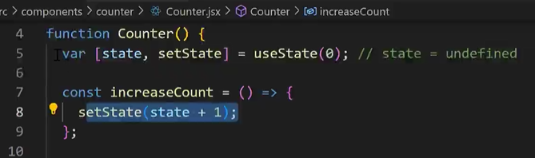

**CODE IN Javascript to increment a counter on UI**

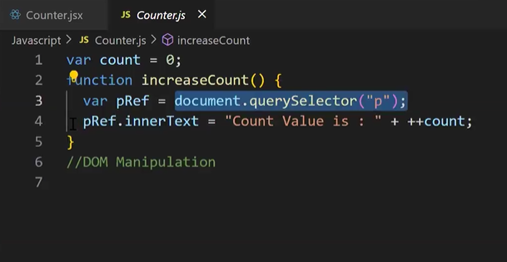

===============**WRONG**

Lot of people say State is an object.But its wrong.State is a Special variable in React where we can store any kind of data.

To pass multiple values in State, you can take Object or you can take array.

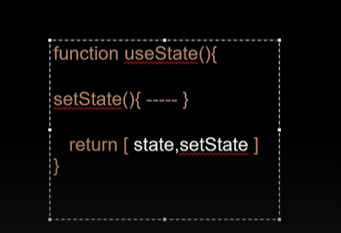

Internally React has written a function called useState(). That function just returns an array which has exactly two variables.I.e state is a special variable and setState() is a function.

We are destructuring the array returned by useState()

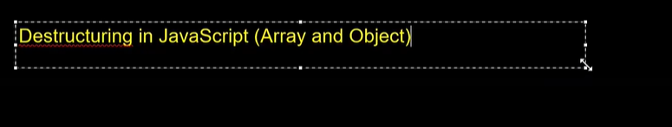

Explore in Javascript how to destructure Array and how to destructure Object

**Any data which is dynamic should come from your state.You can create any number of state variables.Just variable names should not be repeated.**

**SESSION-12**

**Interview questions**

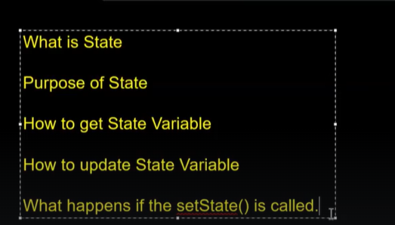

**Interview question:**

**Without using setState(), can we update state variable or not?**

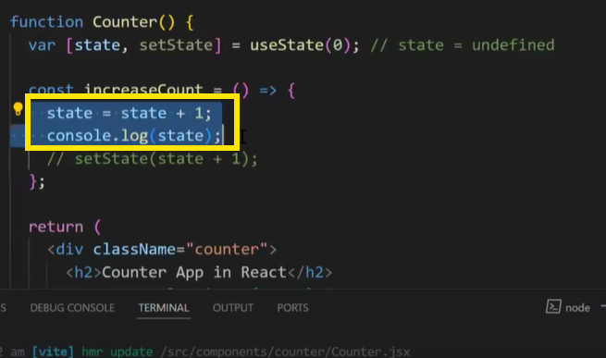

Yes, we can update the state variable without using setState() in normal approach.But in this normal approach, your UI wont get updated.

**Why UI doesnot update?**

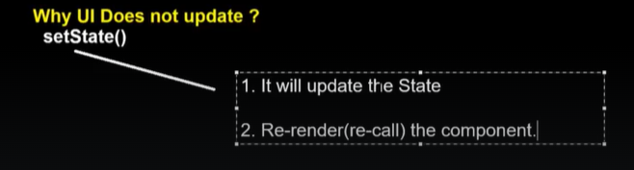

In normal approach, you are rendering UI component for first time and default value of counter is 0.

But when you update state value as shown in above screenshot, you are only updating state value, but you are not re-rendering the UI component.

Re-rendering means updating the DOM.

Therefore we have to tell React to update state and also re-render the component.For that we need to use setState().

**Explain me about setState() --- Interview question**

1. **It will update the state**
2. **Re-render(recall) the component-----------(mentioning second point is very important in interviews) Re-rendering the component means updating the DOM.**

**What happens when you call setState() multiple times in your code?**

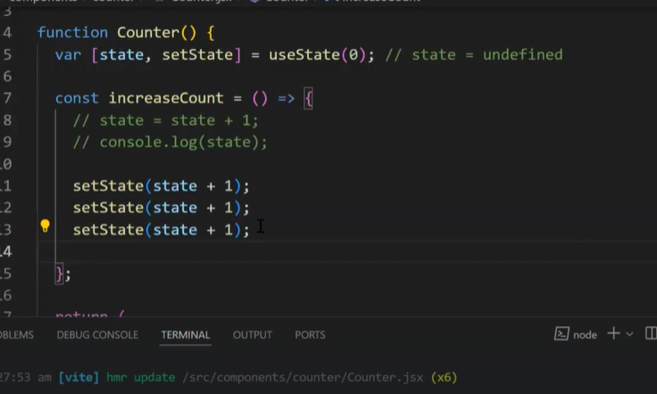

From the above code , try to guess what will be displayed on UI screen below

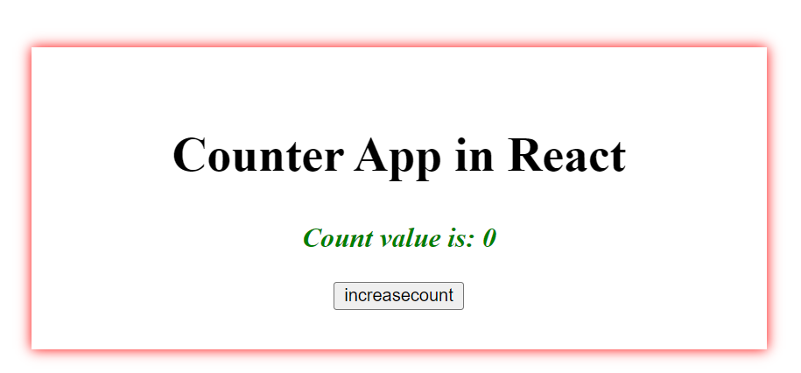

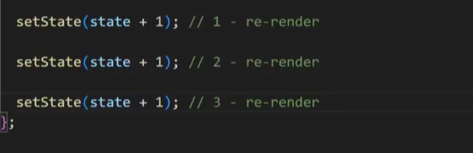

Although in the above screenshot, setState() is called 3 times, re-render happens only one time.

What will be the answer for below case?

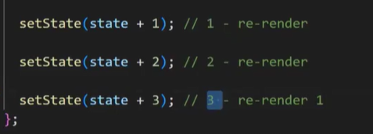

**Answer is 3**

**What will be the answer for below case?**

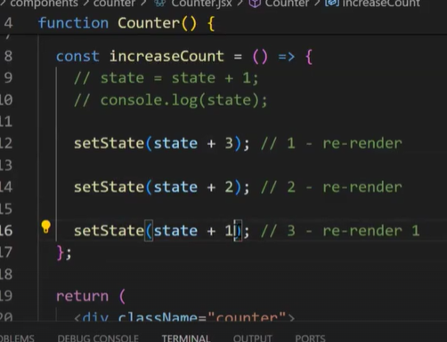

**Answer is 1**

**So basically what happens inside EventHandler is - in this case event handler is increaseCount().**

**In the eventHandler, when you call same setState() multiple times, in that case React internally creates a Queue datastructure.Inside that queue datastructure, it will maintain all setState() calls.**

**Initially it will add setState(state +1) in Queue. Here current value of state is zero**

**Next it will add second setState(state+1) in Queue.Here current value of state is zero**

**Next it will add third setState(state+1) in Queue.Here current value of state is zero**

**So in the baove steps, it will update State value from 0 to 1.After updating the state, it will not immediately re-render.It will check if there are any setState() calls present in queue.If there is any setState() call present, it will evaluate that setState().**

**Only after evaluating all setState() calls, it will re-render with the value present in last setState() call.**

**Instead of re-rendering three times, they are re-rendering only once.Due to this React performance increases a lot.**

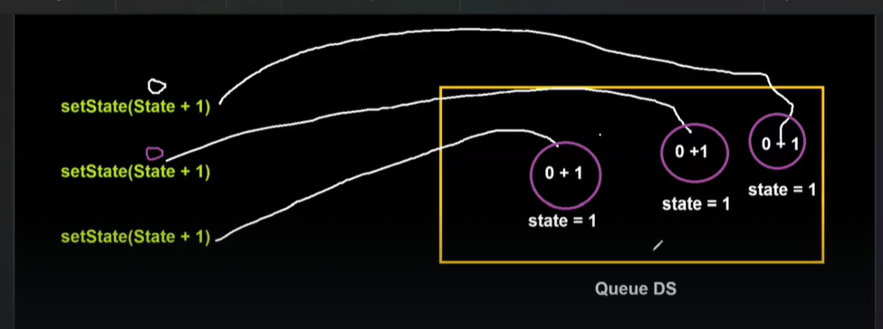

**This is the reason, if we go for any product based companies interviews, they ask Data structures.**

**Data structures are very very important for writing an efficient code.**

**One of the most popular interview question:**

**They will ask you to share the screen and implement counter application**

**They will test your state knowledge with this counter example.**

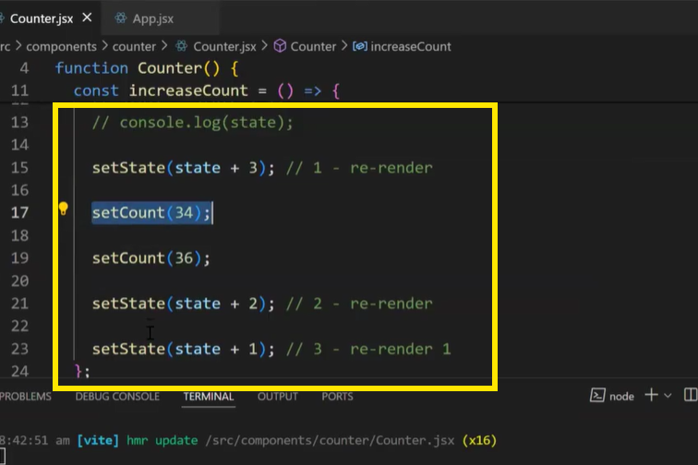

**In the above example, we have two different setter functions setState() and setCount() in the same eventHandler.In this case, then how many times component is re-rendering?**

**Find out answer for this ---assignment**

**For same setter call, it re-renders only one time.**

**Another scenario**

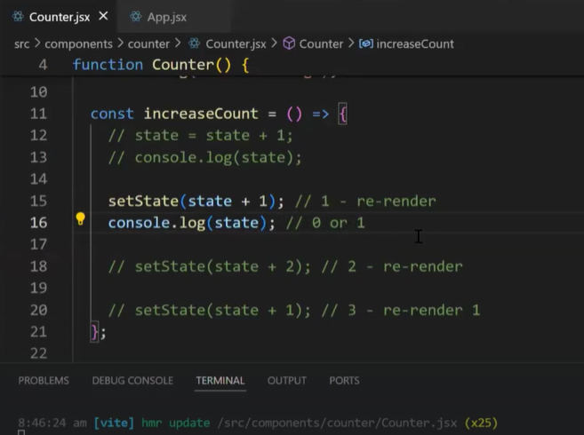

At line no 15, we are updating state value to 1.

But at line 16, when you print state value in the console, it still shows only 0 .Why?

**setState() is asynchronous function.The moment setState() function updates value of state variable, even before that log function gets executed.**

**Since setState() is asynchronous call, its execution gets started in another thread. Where as Main thread executes log().**

**Interview question:**

**Is setState() asynchronous or synchronous function?**

**setState() is asynchronous function and its execution gets started in background.Before it updates state vale to 1, log() function gets executed.**

**Another scenarion:**

**How many time we call setState(), those many times count value should increase?**

**For that setState() will take one call back function.**

**The function that we are passing as an argument to setState() is called Updater function in React.**

**Updater function will take an argument as parameter and that argument is called prevState.**

**Whatever value that is returned by Updater function will be updated inside state variable.**

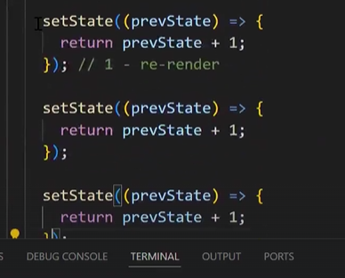

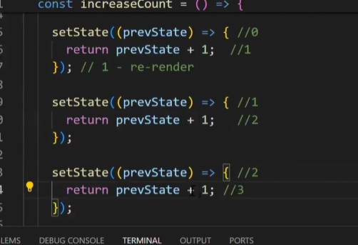

Re-render happens only after evaluation of all three setState() calls.

The moment at which re-rendering is done, state variable value is 3 and that vale is shown on UI.

In Updater function, you will have access of previous state

Even though setState() is asynchronous, the value gets updated correctly because all three setState() calls are asynchronous and they get executed in the background one after other.

When you are calling same setState() multiple times in same event handler and you want that state value gets increased in incremental pattern, then you have to use this updater() function.

Or you can go with manual process of setState(state+1)

**SESSION-13**

**In React, any function that starts with ‘use’ -- that function is called Hook in React.**



**Rules for React Hooks**

**React Hooks we can use only inside Functional component.We cannot use inside class component.**

**React Hooks should be called at the top level of the component.You cannot call them at the end of the functional component.**

**Hooks cannot be called outside the functional component or inside the JSX or inside any event handler.Inside functional component also, you cannot call Hooks inside JSX or inside any event handler.**

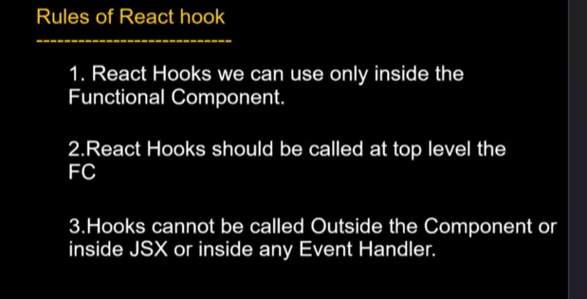

**Interview question**

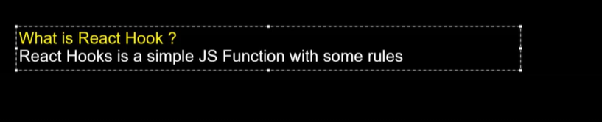

**What are React Hook rules? -- Interview question**

**React 16 got a lot of major changes and from React 16, they started focusing on Functional Programming**

**Before React 16, everybody used to follow Class component.**

**Before React 16, Functional components were used to create only Static User interface.If you want to create any dynamic User Interface, then you have to go with Class component**

**Before React 16, there is no way to use State concept inside your functional component.**

**Interview question:**

**Why React introduced Hooks concept?**

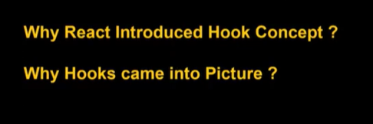Now a days this question is not asked much.But 2-3 years back it was asked more in interviews.

**Routing in React**

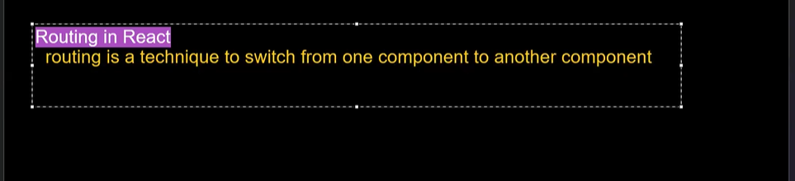



We depend on external libraries

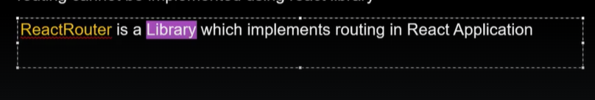

To implement routing in React applications,you have to install and configure ReactRouter in your application



**Few components provided by ReactRouter library.**

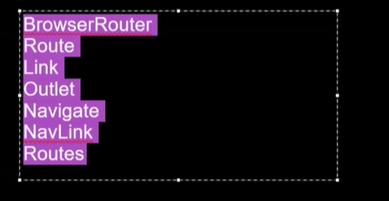

**Few hooks provided by ReactRouter library**

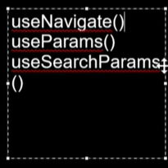

All the above components and hooks are pre-defined by ReactRouter and we just need to use them to implement React routing.

If you want to learn more about React library then visit the below website.

**<https://reactrouter.com/en/main>**

Just like the way how React is a library, ReactRouter is also a library.

To work with ReactRouter, we have to do folllowing steps.



It will keep this library under node_modules folder and register that package under package.json file.To check if it is installed or not go to package.json file and check under dependencies

node_modules is a folder that contain all packages that are required for your application.



Package is similar to library and npm is a library manager

**Why are we using npm?**

**When you want to download and install some x library, you need to know the location of that library.You have to go to that location, then you have to download and install the library.**

**Suppose this x library is internally dependent on some x1 library.Which means x library has some predefined functions and implementation of those functions is present in x1 library.**

**Therefore to work with x library, you have to install x1 library also.**

**And to install x1 library, you have to go to location of x1 library, you need to download and install that library.**

**Additionally you should take care of versioning also.**

**Suppose 5th version of x library is dependent on 7th version of x1 library.If you install 1st version of x1 library, then x library will not work because it depends on 7th version of x1 library.**

**Further x1 library can be dependent on x2 library and x2 library can be dependent on x3 library.so you have to take care of downloading , installing and versions also.**

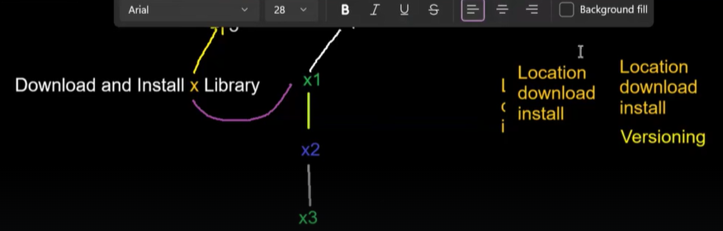

**Doing all these things by developer is very tough .So we are using Package manager.That package manager is NPM which we got from Node software.**

**When we have installed Node JS, internally this package manager also got installed.This tool is of Node JS.**

**Node JS team created a repository which contains all Java script libraries.**

**So when we install ReactRouter library, npm will install that library from the above repository and also installs dependent libraries.**

**All these libraries will be downloaded and kept under node_modules folder**

**We are using npm for managing our packages.**

**As a developer we need to focus on Application functionality.**

**SESSION-14**



To implement routing, we need to do certain configurations.

There are some pre-defined components and hooks provided by React-router library.



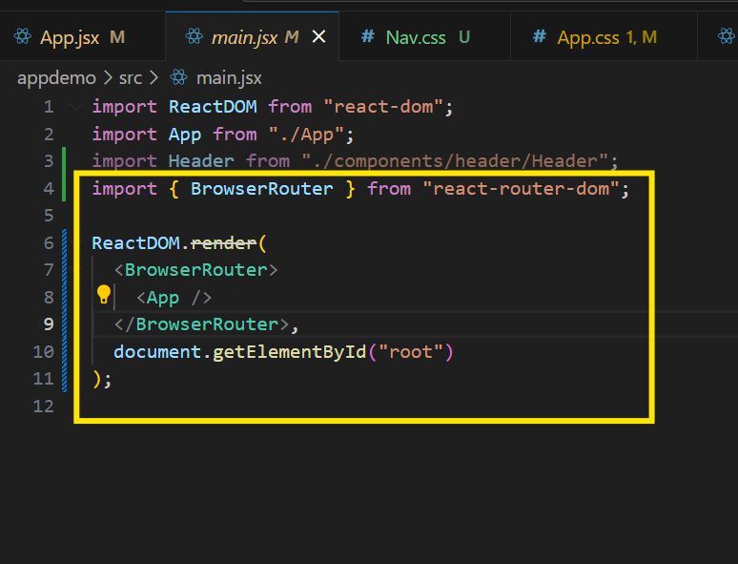



The url present after the port number is url path.

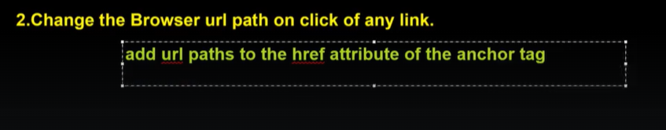

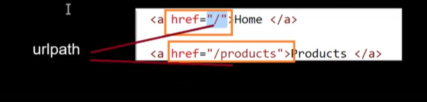

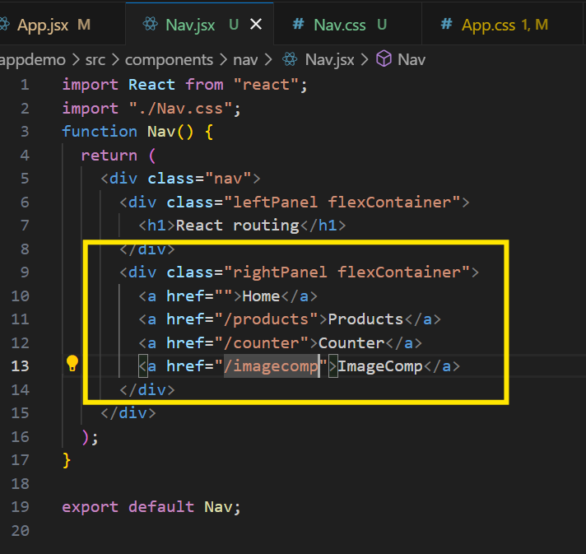

When you click on Home, it will not redirect to any other component.so we did not give any URLpath for anchor tag of Home

**Step3: Configure the route**

Based on URL path, you have to render the component.(show the component on screen)

**Import {Route} from ‘react-router-dom’**

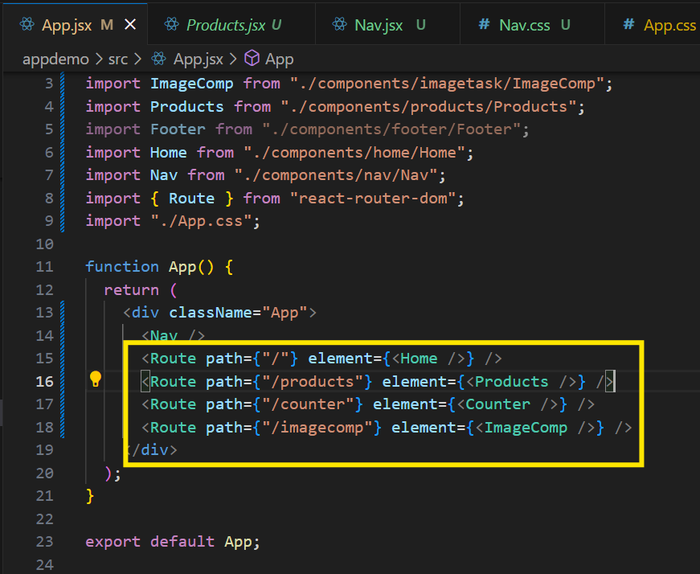

The value given in path Props should be equal to value given in href attribute of anchor tags



**Import {Route,Routes} from ‘react-router-dom’**

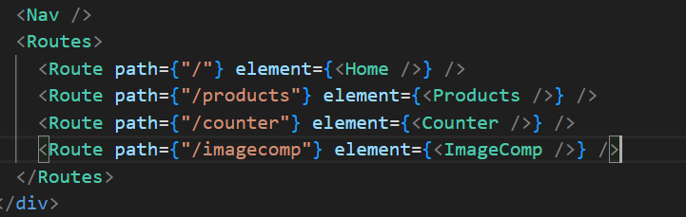

Problem: Whenever you are clicking on optiosn displayed on Nav bar, the page is reloading.

With React we are creating Single Page Applications and SPA should not reload.If you reload, you will loose current state of the application.We will loose the data that we got after clicking some buttons.So we have to restrict that.

For that react provides one solution.

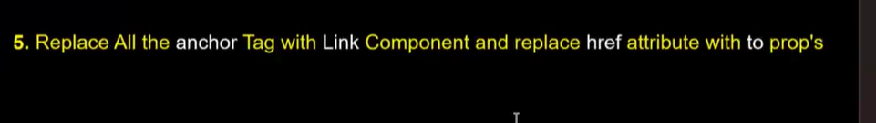

import { Link } from "react-router-dom";

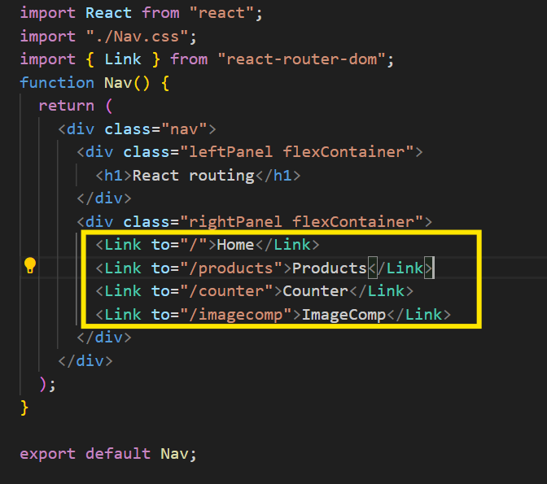

Now the page wont reload and the performance is very fast.



Single Page Applications are very fast compared to your multi page applications.

In multi page applications, you will have multiple HTML documents which you are going to load in your browser each and every time whenever user requests any kind of page.

Based on user actions, you will remove some pages and load some other pages.

In Single Page Applications, we are going to load only single HTML document on browser.

**Examples of SPA are Netflix, gmail, Instagram,Airbnb,Gitlabs etc…**

Whenever you visit any kinds of links, the page will not reload

Gmail is developed by google and they internally used Angular.

Instagram,Airbnb,Netflix are developed using React

Gitlabs is developed using VueJS.

Here React and Angular are taking care of developing SPAs and dynamically they are changing the content.As a developer, we are not writing any code to get Single Page Application behaviour.

But if you use plain Java script,first you have to write code for developing the application and then later you have to write code for making it Single Page Application.It will be more burden for us.That is the reason why we are using Frameworks and libraries as well.

By default, all the applications that are developed using Angular and React are Single Page Applications.Only Single document will be loaded in our browser.For entire application, we have Single HTML file and only that HTML file is loaded in browser.

To develop Multi page applications, you can use normal HTML,CSS,Javascript.



When you want to load one component inside another component, then you have to use **<Outlet/>** component provided by React

Outlet is like a container which will hold your subcomponents

**<Outlet/>** component is a pre-defined component which comes from a **react-router-dom**

**SESSION-15**

Whether you change the URL path by clicking any link or manually, it still behaves the same.

When user tries to access URL path that is not configured, then we display page not found error.

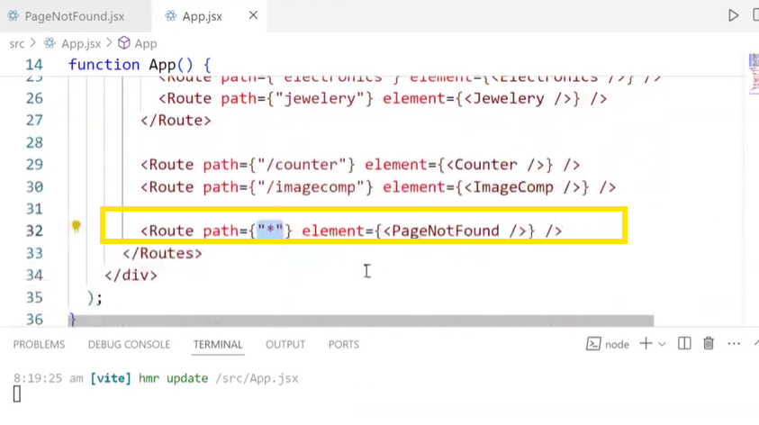

**Wild route: Above highlighted route is called Wild route.It will be execute for each and every URL that you enter even if it’s a valid URL.That’s why it is added at last in Routes configuration.**

**Don’t add it in between anywhere because it will match with each and every path.**

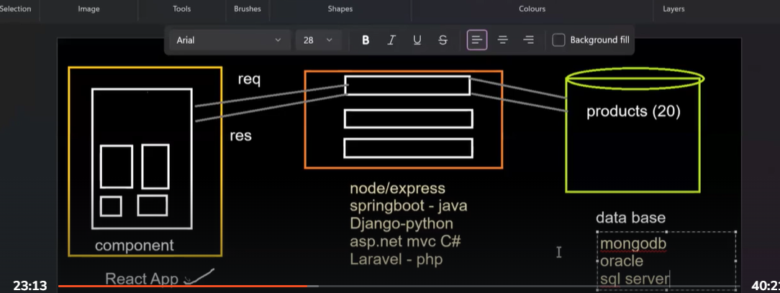

As we don’t have backend application now we take help of Fake APIs.

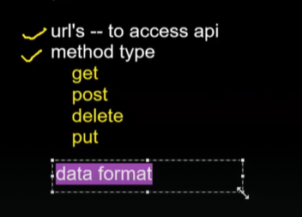

URLs to access api, method type and data formal === all these three will be given by Backend people

**How to send a request from React application to backend application?**

There are multiple ways to send request to backend and get response from backend.

1. axios --very popular in React projects.Using axios library, we can do network calls.
2. fetch() - Browser is providing one predefined function(API) called fetch().
3. Ajax -- core way to do network calls. --Outdated

Axios and fetch() --internally these two are implementing AJAX only.



**Steps to do to perform Network calls**

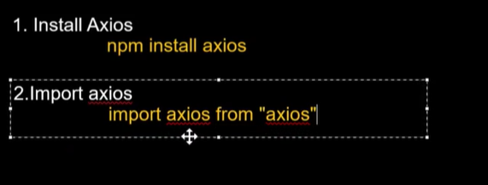

In which ever component you want to implement the logic of sending request to a server, there you need to import axios

When you import axios, it will export an object

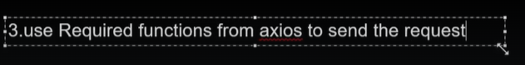

axios.get()

axios.put()

axios.post()

axios.delete()

By using above predefined functions we can send requests to a server.

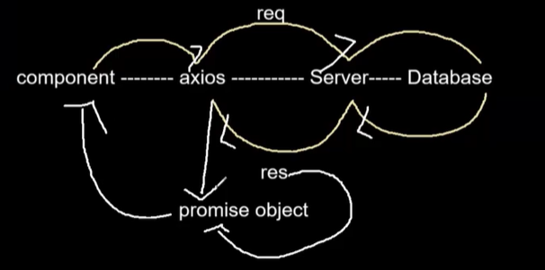

Axios will create a promise object.Whatever the data returned by the server, axios will add that data to promise object and returns that promise object to us.

Whenever you call axios.get() it will return one Promise object.And to access the data from Promise object we have two ways.

1. **then catch**
2. **async await**

Promise Concept

------------------

https://youtu.be/ialfZyeAbaY?si=hy7dchbPbstodwjC

useParams, useSearchParams,Protected Routes

---------------------------------------------

https://youtu.be/dBEZdF1zHPc?si=YsmLjnM6qI97oKs0

useEffect() hook

-----------------

Part-1

-----------

https://youtu.be/2UpyWRfigME?si=Jj-Tndrbel999M2P

Part-2

---------

https://youtu.be/s0Os0M9xhGE?si=HzD334jk3hmmORsz

class Component

-----------------

https://youtu.be/r9WXv2s3wQ0?si=WgJN5vXC36WQJPzt

Lifecycle Methods in class Component

-------------------------------------

<https://youtu.be/3C2QNdPDIi8?si=P5cFAtrvsMWkTx_K>

Revise flex in css, grid in css, JS topics

On Github , under session-15 notes, pdf attached for flex and grid concept

**SESSION-16**

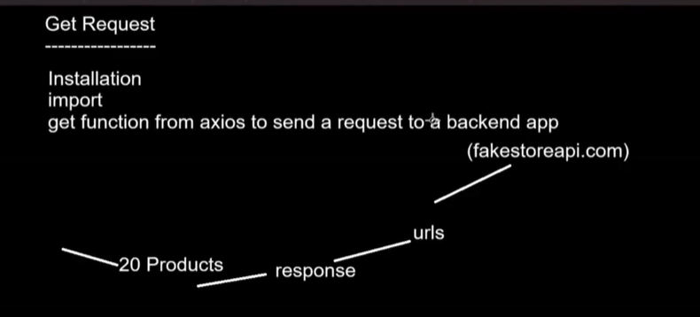

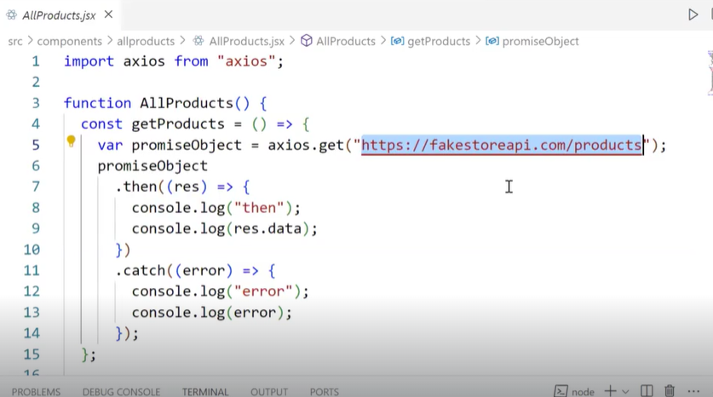

The best way for looping in React is Map function. Map comes from Javascript

Once we get the data from the server, we are adding that data inside the State.The state contains an array of 20 objects



**Map function cannot be used on objects.You can use it only on array.In your JSX if you are using map on any state, then it is mandatory that the state should contain Array as data.Apart from array, if that state contains any other kind of data, then we cannot use map.**

**SESSION-17**

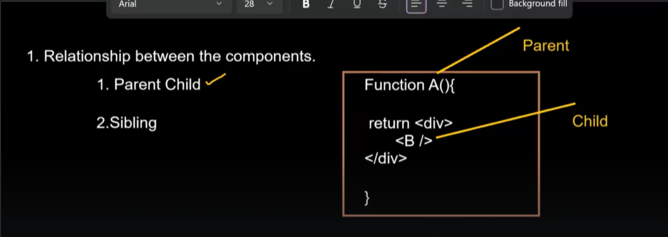

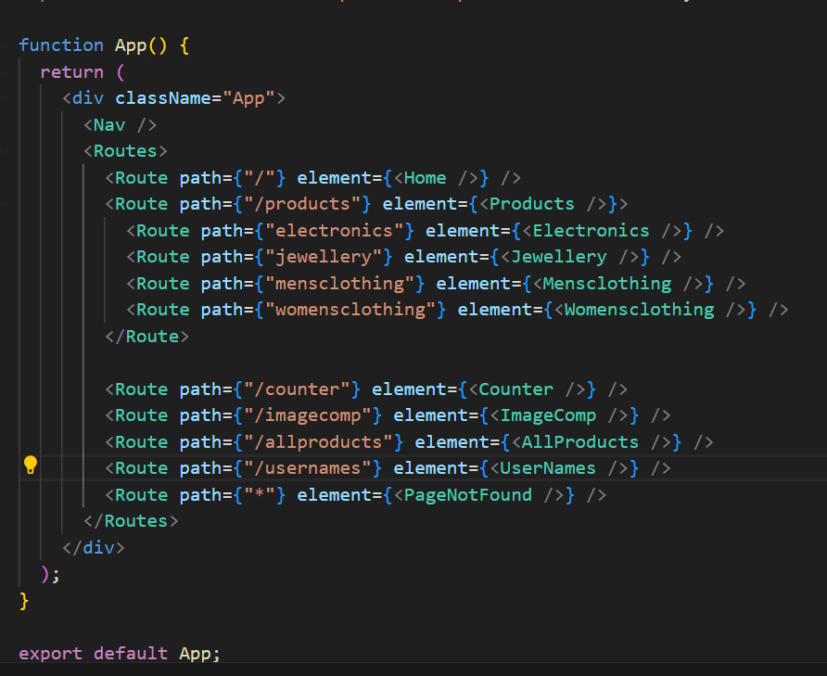

Here App and Nav are in parent-child relationship where App is called Parent and Nav is called child

Here App and Home are in parent-child relationship where App is called Parent and Home is called child.

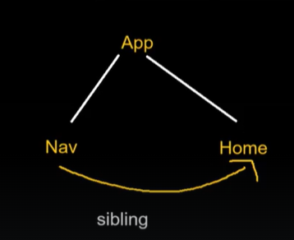

Here Nav and Home are in sibling relationship because they both have common parent.

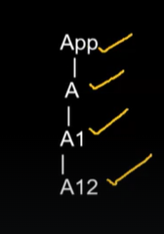Here component A is child of App component and A1 is child of A and A12 is child of A1

A is direct child of App component, because under App we are directly rendering A.

App and A1 are in parent-child relationship.But A1 is indirect child of App component.

For A1, A is a direct parent and App is indirect parent

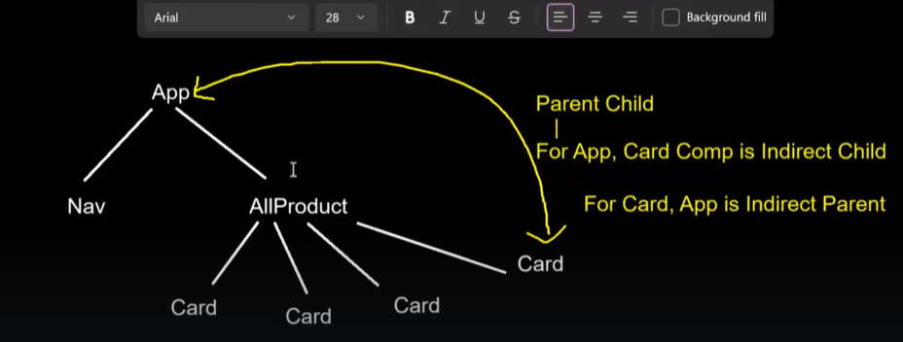

In this case Nav and Card are having Sibling relationship.

AllProduct and Card is having Parent-child relationship



**One more use of Props: share the data from parent component to child component.**

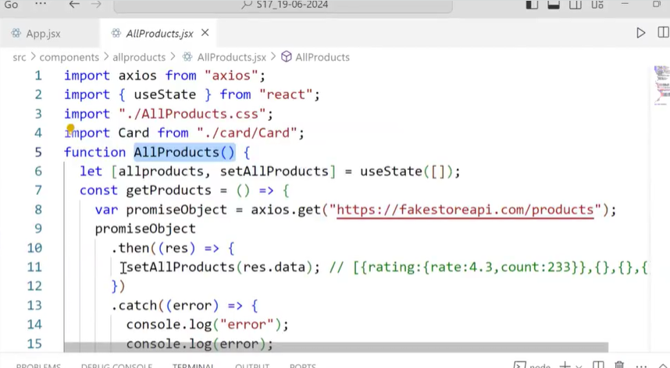

Here we are fetching the data from server in AllProducts component and storing in state.

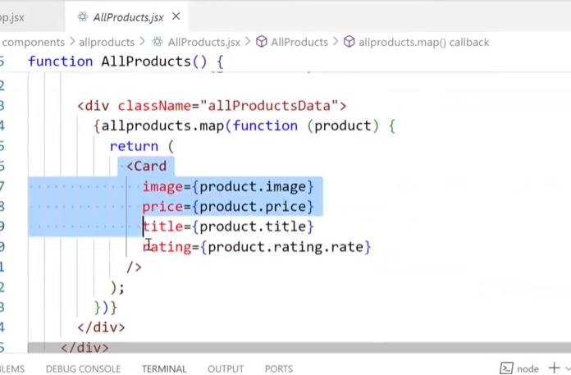

We are passing that data to Card component using the concept of Props.

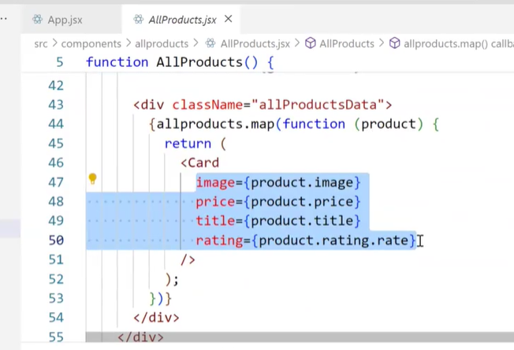

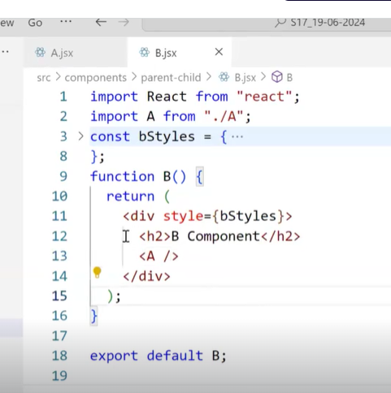

Here B is parent component and A is child component

Whnever you want to share data from parent to child, you can use concept of Props

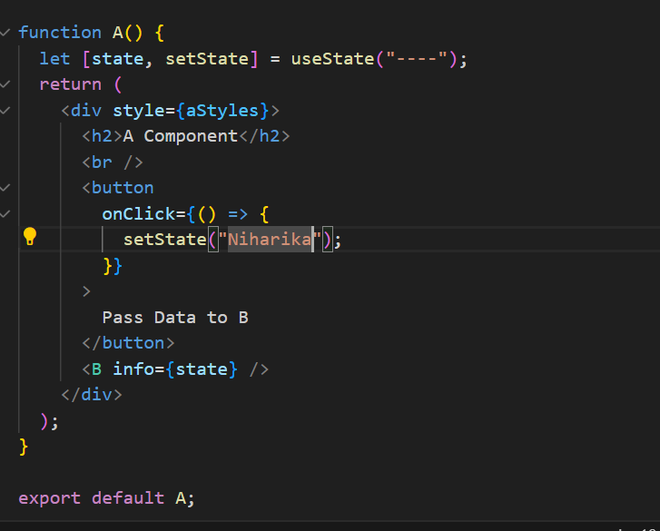

In the above code,by default, state value is “---”. When user clicks on button, setState() is called and state values is updated to Niharika.

setState() not only updates State value but also renders the component.As a result component A and since component B is present within A, both A and B are rendered.

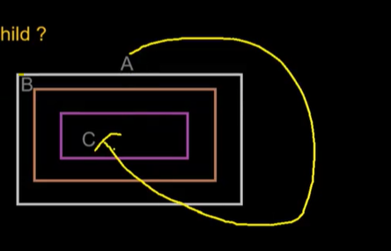

In this scenario, how to share data from component A to component C?

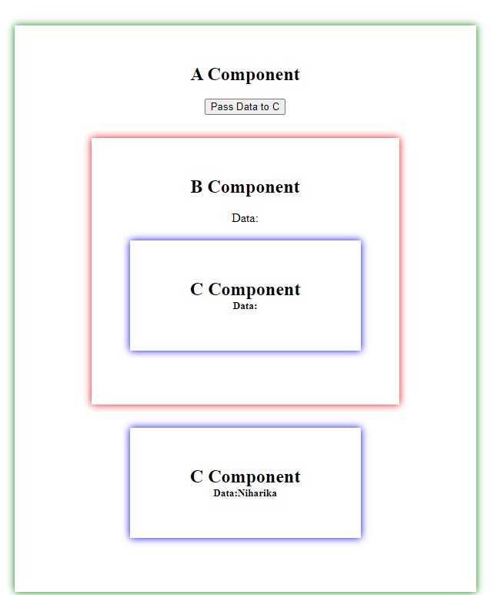

You can pass directly from A to C, only when C is direct child of A as shown above

But you cannot pass data directly from A to C, when C is indirect child of A.In this case, you need to pass data from A to B and then from B to C.

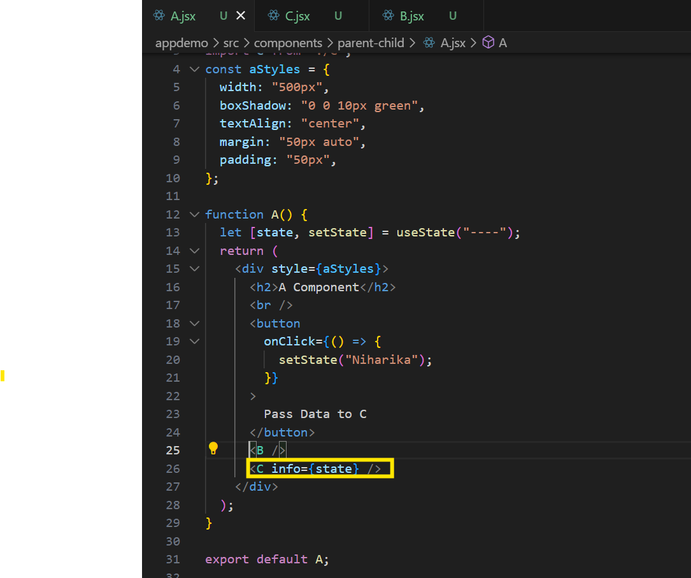

There are some predefined components and in that case you have to use predefined keys of that component

Whereas if you define components, then you can use keys of your own